

**RAILWAY MANAGEMENT**

A Project Report Submitted

in Partial Fulfillment of the Requirements

**AISSCE - All India Senior School Certificate Examination 2020-2021: SCIENCE – XII A/B/C**

In

**COMPUTER SCIENCE (083)**

**Submitted by : Aditya rathore Class : 12 A**

**KENDRIYA VIDYALAYA NO.3 MORAR CANTT**

**GWALIOR**

**Submitted to : Mrs. Sangeeta M Chauhan**

**INDEX**



|  |  |  |
| --- | --- | --- |
| Serial number | Topic | Page number |
| 1. | **Undertaking** | **3** |
| 2. | **Certificate** | **4** |
| 3. | **Acknowledgement** | **5** |
| 4. | **Content** | **6** |
| 5. | **Introduction to the project** | **7** |
| 6. | **System reqirements of**  **the projects** | **8** |
| 7. | **Coding** | **9-110** |
| 8. | **Screenshots of outputs** | **111-178** |
| 9. | **Screenshots of MySQL** | **178-181** |
| 10. | **References** | **182** |
|  |  |  |
|  |  |  |
|  |  |  |

**UNDERTAKING**

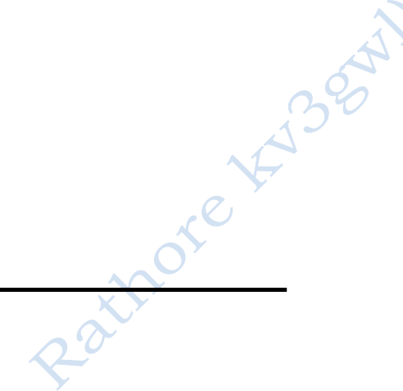

### We declare that the work presented in this project titled

**RAILWAY MANAGEMENT,** submitted to **Smt. Sangeeta M**

**Chauhan PGT- Computer Science, Kendriya Vidyalaya NO.3 Morar Cantt , Gwalior**

for the award of the **CBSE – AISSCE class XII certificate**. I

### have not plagiarized or submitted the same work for the award of any other examination. In case this undertaking is found incorrect, we accept that our Certificates may be unconditionally withdrawn.



**CERTIFICATE**

### Certified that the work contained in the project titled

**RAILWAY MANAGEMENT** , by **ADITYA RATHORE ,** has

### been carried out under my supervision and that this work has not been submitted elsewhere for a AISSE certificate.

**Project Guide:**

**Sangeeta M Chauhan PGT-Computer Science Kendriya Vidyalaya 3 ,**

**Gwalior**

**( RAGHVENDRA LALSANTANIA)**

**PRINCIPAL KENDRIYA VIDYALAYA NO.3 GWALIOR**

**Acknowledgements**



I would like to express my special thanks of gratitude to my teacher Mrs. Sangeeta M Chauhan as well as our principal Mr. Raghvendra lalsantania who gave me the golden opportunity to do this wonderful project on the topic Railway management , which also helped me in doing a lot of Research and I came to know about so many new things I am really thankful tothem.

Secondly i would also like to thank my parents and friends who helped me a lot in finalizing this project within the limited time frame.



**Contents**

1. Introduction of the Project.
2. System Requirements of the Project.
3. Python Coding.
4. Output of the Project.
5. Screenshots of MySQL
6. References.

**Introduction of the Project**

This project is similar to an Indian Railway app. It allows the user to book, cancel, modify or view , their respective bookings. It allows the admin to change the train’s records and their records. In this project



there is also an option, for user in Indian railway.



registering the

## SYSTEM REQIREMENTS OF PROJECTS :



1. Windows operating system
2. Python IDLE 3.MySQL

4.MySQL connector

# :



CODING



import connectorfunction as a import connfunatt as c



print('Type 1 for running the application') print('Type 2 for database related queries') choice=input('1-2 : ')

if choice == '1' : a.welcometoindianrailways()

elif choice == '2' :

c.databaserelatedqueries()



else :

exit()

**MODULE 1 : connectorfunction**

import mysql.connector as myc



conn=myc.connect(host='localhost', user= 'root', passwd='student',database='railway_ticketing_software')

d=conn.cursor()

import gtts

from playsound import playsound import os

import re

def userid() :

m=input('User id(6 digits ),numeric : ') ln=len(m)

regex = re.compile('[-@!#$% ^_&*()<,.+>?/\|}{~:]') if (regex.search(m) != None ):

print("Special characters are not allowed") m=userid()

else :

if (m.isalpha()) :

print('Only numerals are allowed' , ' \U0001F610') m=userid()



elif (m.isnumeric()) :

if ln != 6 :

print('User id should be of 6 numerals ', ' \U0001F610') m=userid()

elif (not m.isdigit() and not m.isalpha() ) :

print('Only numerals are allowed ', ' \U0001F610') m=userid()

return m def a() :

m=input('User id(6 digits ),numeric :') import mysql.connector as myc

conn=myc.connect(host='localhost', user= 'root', passwd='student',database='railway_ticketing_software')

d=conn.cursor()

qr='select * from user_info where user_id =% s ' va=(m,)

d.execute(qr,va) f=d.fetchall() rw=d.rowcount

regex = re.compile('[-@!#$% ^_&*()<,.+>?/\|}{~:]') if(regex.search(m) != None ):



print("Special characters are not allowed") m=a()

else :

if rw == 1 :

print('User id exist , please select another user id ', '

\U0001F610')

m=a() else

:

ln=len(m)

if (m.isalpha()) :

print('Only numerals are allowed', ' \U0001F610') m=a()

elif (m.isnumeric()) :

if ln != 6 :

print('User id should be of 6 numerals ', '

\U0001F610')

m=a()

elif (not m.isdigit() and not m.isalpha() ) :

print('Only alphabets are allowed ', ' \U0001F610')

m=a() else :



print('Only numerals are allowed', ' \U0001F610') m=a()

return m def username() :

n=input('User name(Use undersore(_) instead of space ) : ') regex = re.compile('[-@!#$% ^&*()<,.+>?/\|}{1234567890~:]') if(regex.search(n) == None ):

print("Accepted ") else :

if ( n.isdigit()) :

print('Only alphabets are allowed ', ' \U0001F610') n=username()

elif (not n.isdigit() and not n.isalpha() ) :

print('Only alphabets are allowed ', ' \U0001F610') n=username()

return n def nusername() :

n=input('User name(Use undersore(_) instead of space ) : ') regex = re.compile('[-@!#$% ^&*()<,.+>?/\|}{1234567890~:]')

if(regex.search(n) == None ): print("Accepted ")



else :

if ( n.isdigit()) :

print('Only alphabets are allowed ', ' \U0001F610') n=username()

elif (not n.isdigit() and not n.isalpha() ) :

print('Only alphabets are allowed ', ' \U0001F610') n=username()

return n

def c() :

o=input('User age : ') ln=len(o)

regex = re.compile('[-@!#$% ^_&*()<,.+>?/\|}{~:]') if(regex.search(o) != None ):

print("Special characters are not allowed") o=c()

else :

if (o.isalpha()) :

print('Only numerals are allowed',' \U0001F610') o=c()

elif(o.isnumeri c()) : op=int(o) if(op > 116) :



print('Invalid age ', ' \U0001F610') o=c()

elif (not o.isnumeric() and not o.isalpha() ) :

print('Only alphabets are allowed ', ' \U0001F610') o=c()

else :

print('Only numerals are allowed', ' \U0001F610') o=c()

return o

def nc() :

o=input('Enter new user age : ')

regex = re.compile('[-@!#$% ^_&*()<,.+>?/\|}{~:]') if(regex.search(o) != None ):

print("Special characters are not allowed") o=nc()

else :

ln=len(o)

if (o.isalpha()) :

print('Only numerals are allowed', ' \U0001F610') o=nc()



elif(o.isnumeri c()) : op=int(o) if(op > 116) :

print('Invalid age ', ' \U0001F610') o=nc()

elif (not o.isnumeric() and not o.isalpha() ) :

print('Only alphabets are allowed ', ' \U0001F610') o=nc()

else :

print('Only numerals are allowed', ' \U0001F610') o=nc()

return o

def da () :

p=input('User gender : ') ln=len(p)

ph=['m','f'] pk=p.lower()

regex = re.compile('[-@!#$% ^_&*()<,.+>?/\|}{~:]') if(regex.search(p) != None ):

print("Special characters are not allowed") p=da()



else :

if (p.isnumeric()) :

print('Only alphabets are allowed', ' \U0001F610') p=da()

elif (p.isalpha())

: if ln != 1 :

print('Gender should be of 1 characters (m or f )', '

\U0001F610')

p=da()

elif pk != ph[0] and pk != ph[1] : print('Only m and f are allowed ') p=da()

elif (not p.isnumeric() and not p.isalpha() ) : print('Only alphabets are allowed ', ' \U0001F610') p=da()

return p

def e() :

q=input('User mobile no(10 digits ),numeric : ')

ln=len(q)

regex = re.compile('[-@!#$% ^_&*()<,.+>?/\|}{~:]') if(regex.search(q) != None ):



print("Special characters are not allowed") q=e()

else :

if (q.isalpha()) :

print('Only numerals are allowed', ' \U0001F610') q=e()

elif (q.isnumeric()) :

if ln != 10 :

print('Mobile number should be of 10 numerals ',

' \U0001F610')

q=e()

elif (not q.isnumeric() and not q.isalpha() ) :

print(' Only numerals are allowed ', ' \U0001F610') q=e()

return q def ne()

:

q=input('Enter new mobile number(10 digits ),numeric : ') ln=len(q)

regex = re.compile('[-@!#$% ^_&*()<,.+>?/\|}{~:]')

if(regex.search(q) != None ):

print("Special characters are not allowed") q=ne()



else :

if (q.isalpha()) :

print('Only numerals are allowed', ' \U0001F610') q=ne()

elif (q.isnumeric()) :

if ln != 10 :

print('Mobile number should be of 10 numerals ',

' \U0001F610')

q=ne()

elif (not q.isdigit() and not q.isalpha() ) :

print('Only numerals are allowed ', ' \U0001F610') q=ne()

return q

def fa() :

r=input('Password(4 digits),numeric : ') ln=len(r)

regex = re.compile('[-@!#$% ^_&*()<,.+>?/\|}{~:]')

if(regex.search(r) != None ):

print("Special characters are not allowed") r=fa()



else :

if (r.isalpha()) :

print('Only numerals are allowed', ' \U0001F610') r=fa()

elif (r.isnumeric())

: if ln != 4 :

print('Password should be of 4 numerals ', '

\U0001F610')

r=fa()

else :

print('Only numerals are allowed', ' \U0001F610') r=fa()

return r

def nfa() :

r=input('Enter new password(4 digits),numeric : ') ln=len(r)

regex = re.compile('[-@!#$% ^_&*()<,.+>?/\|}{~:]')

if(regex.search(r) != None ):

print("Special characters are not allowed") n=nfa()



else :

if (r.isalpha()) :

print('Only numerals are allowed', ' \U0001F610') r=nfa()

elif (r.isnumeric())

: if ln != 4 :

print('Password should be of 4 numerals ', '

\U0001F610')

r=nfa()

else :

print('Only numerals are allowed', ' \U0001F610') r=nfa()

return r def trainid() :

r=input('Enter train id(5 digits),numeric : ') ln=len(r)

regex = re.compile('[-@!#$% ^_&*()<,.+>?/\|}{~:]') if(regex.search(r) != None ):

print("Special characters are not allowed")

r=trainid() else :



if (r.isalpha()) :

print('Only numerals are allowed', ' \U0001F610') r=trainid()

elif (r.isnumeric())

: if ln != 5 :

print('Train id should be of 5 numerals ', ' \U0001F610') r=trainid()

else :

print('Only numerals are allowed', ' \U0001F610') r=trainid()

return r

def newtrainid() :

r=input('Train id(6 digits ),numeric :') ln=len(r)

import mysql.connector as myc

conn=myc.connect(host='localhost', user= 'root', passwd='student',database='railway_ticketing_software')

d=conn.cursor()

qr='select * from trains_info where train_id =% s ' va=(r,)



d.execute(qr,va) f=d.fetchall() rw=d.rowcount

regex = re.compile('[-@!#$% ^_&*()<,.+>?/\|}{~:]') if(regex.search(r) != None ):

print("Special characters are not allowed") r=trainid()

else :

if rw==1 :

print('Train with given id is already registered') r=newtrainid()

else :

if (r.isalpha()) :

print('Only numerals are allowed', ' \U0001F610') r=trainid()

elif (r.isnumeric())

: if ln != 5 :

print('Train id should be of 5 numerals ', ' \U0001F610') r=trainid()

else :

print('Only numerals are allowed', ' \U0001F610') r=trainid()



return r def trainname() :

n=input('Train name(Use undersore(_) instead of space ) : ') regex = re.compile('[-@!#$% ^&*()<123456789,.+>?/\|}{~:]') if(regex.search(n) == None ):

print("Accepted") else :

if ( n.isdigit()) :

print('Only alphabets are allowed ', ' \U0001F610') n=trainname()

elif (not n.isdigit() and not n.isalpha() ) :

print('Only alphabets are allowed ', ' \U0001F610') n=trainname()

return n def trsource() :

n=input('Enter source : ')

regex = re.compile('[-@!#$% ^_&*()<,.+>?/\|}{~:]') if(regex.search(n) != None ):

print("Special characters are not allowed") n=trsource()



else :

if ( n.isdigit()) :

print('Only alphabets are allowed ', ' \U0001F610') n=trsource()

elif (not n.isdigit() and not n.isalpha() ) :

print('Only alphabets are allowed ', ' \U0001F610') n=trsource()

return n def trdestination() :

n=input('Enter destination : ')

regex = re.compile('[-@!#$% ^_&*()<,.+>?/\|}{~:]') if(regex.search(n) != None ):

print("Special characters are not allowed") n=trdestination()

else :

if ( n.isdigit()) :

print('Only alphabets are allowed ', ' \U0001F610') n=trdestination()

elif (not n.isdigit() and not n.isalpha() ) :

print('Only alphabets are allowed ', ' \U0001F610') n=trdestination()



return n def trinterstations() :

n=input('Enter interstations(seperated with commas(,) : ') regex = re.compile('[-@!#1234567890$%^_&*()<.+>?/\|}{~:]') if(regex.search(n) != None ):

print("Special characters are not allowed") n=trinterstations()

else :

if ( n.isdigit()) :

print('Only alphabets are allowed(seperated with commas(,) ', '

\U0001F610')

n=trinterstations() elif ( n.isalpha() ) :

print('Only alphabets are allowed(seperated with commas(,) ', '

\U0001F610')

n=trinterstations() return n

def trfare() :

n=input('Enter fare(seperated with commas(,) : ')

regex = re.compile('[- @!#$%^_&*()<.+>qwertyuioplkjhgfdsazxcvbnm?/\|}{~:]')



if(regex.search(n) != None ):

print("Special characters are not allowed") n=trfare()

else :

if (n.isdigit()) :

print('Only numerals are allowed(seperated with commas(,) ', '

\U0001F610')

n=trfare()

elif ( n.isalpha() ) :

print('Only numerals are allowed(seperated with commas(,) ', '

\U0001F610')

n=tr() return n

def ntrainname() :

import re

import mysql.connector as myc conn=myc.connect(host='localhost', user= 'root',

passwd='student',database='railway_ticketing_software')

d=conn.cursor() n=trainname()



qr=('select * from trains_info where train_name=% s') vl=(n,)

d.execute(qr,vl) f=d.fetchall() rw=d.rowcount if rw!=1 :

regex = re.compile('[-@!#$% =^&*()<,.+>?/\|}{~:]') if(regex.search(n) == None ):

print("Accepted") else

:

if ( n.isdigit()) :

print('Only alphabets are allowed(Use undersore(_) instead of space ) ', ' \U0001F610')

n=ntrainname() if ( n.isdigit()) :

print('Only alphabets are allowed(Use undersore(_) instead of space ) ', ' \U0001F610')

n=ntrainname()

else :

print('Train with same name already exists please select another name ') n=ntrainname() return



n

def ntrsource() :

n=input('Enter new source : ')

regex = re.compile('[-@!#$% ^_&*()<,.+>?/\|}{~:]') if(regex.search(n) != None ):

print("Special characters are not allowed") n=ntrsource()

else :

if ( n.isdigit()) :

print('Only alphabets are allowed ', ' \U0001F610') n=ntrsource()

elif (not n.isdigit() and not n.isalpha() ) :

print('Only alphabets are allowed ', ' \U0001F610') n=ntrsource()

return n def ntrdestination() :

n=input('Enter new destination : ')

regex = re.compile('[-@!#$% ^_&*()<,.+>?/\|}{~:]') if(regex.search(n) != None ):



print("Special characters are not allowed") n=ntrdestination()

else :

if ( n.isdigit()) :

print('Only alphabets are allowed ', ' \U0001F610') n=ntrdestination()

elif (not n.isdigit() and not n.isalpha() ) :

print('Only alphabets are allowed ', ' \U0001F610') n=ntrdestination()

return n def ntrinterstations() :

n=input('Enter new interstations(seperated with commas(,) : ') regex = re.compile('[-@!#1234567890$%^_&*()<.+>?/\|}{~:]') if(regex.search(n) != None ):

print("Special characters are not allowed") n=ntrinterstations()

else :

if ( n.isdigit()) :

print('Only alphabets are allowed(seperated with commas(,) ', '

\U0001F610')



n=ntrinterstations() elif ( n.isalpha() ) :

print('Only alphabets are allowed(seperated with commas(,) ', '

\U0001F610')

n=ntrinterstations() return n

def ntrfare() :

n=input('Enter new fare(seperated with commas(,) : ')

regex = re.compile('[- @!#$%^_&*()<.+>qwertyuioplkjhgfdsazxcvbnm?/\|}{~:]')

if(regex.search(n) != None ):

print("Special characters are not allowed") n=ntrfare()

else :

if (n.isdigit()) :

print('Only numerals are allowed(seperated with commas(,) ', '

\U0001F610')

n=ntrfare() elif ( n.isalpha() ) :

print('Only numerals are allowed(seperated with commas(,) ', '

\U0001F610')



n=ntrfare() return n

def makeadmin() :# only a existing admin can make a new admin

import mysql.connector as myc

conn=myc.connect(host='localhost', user= 'root', passwd='student',database='railway_ticketing_software')

d=conn.cursor()

print('The new admin should be registerd in indian railways ') print('Enter the details of new admin ')

nm=username() af=userid()

qr = 'select * from user_info where user_name=% s and user_id=% s ' az=(nm,af)

d.execute(qr,az) f=d.fetchall() rw=d.rowcount if rw==1 :

for x in f :

if x[6] == 'user' :

qr='update user_info set role = "admin" where user_name=% s and user_id=% s '



az=(nm,af) d.execute(qr,az) conn.commit() goback()

elif x[6] == 'admin' :

print('User with the given id and user name is already admin

')



goback()

else :

print("User not found !") goback()

conn.close()

def goback() : # a function for going back print('')

print('Type 1 to go back')

print('Type 2 to quit the application ') print('')

playsound("enter the valid number out of the numbers given above

.mp3")



cd=input('1-2 : ') if cd=='1' :

playsound("goingback.mp3") welcometoindianrailways() elif cd

=='2' :

exit() else :

welcometoindianrailways() def add_train() : # for admin only

import mysql.connector as myc

conn=myc.connect(host='localhost', user= 'root', passwd='student',database='railway_ticketing_software')

d=conn.cursor() print('************Welcome**************') print('')

print('Type 1 to see the train details ') print('Type 2 to make a new entry in the table ') print('Type 3 to go back to home page ') print('Type 4 to quit the application ')

playsound("enter the valid number out of the numbers given above .mp3") ab=input('1-4 : ')



print('')

if ab =='1' :

playsound("showingtherecordsinthetabletrainsinfo.mp3") print('****************************** records of

trains*********************************')

d.execute('select * from trains_info ') c=d.fetchall()

rw=d.rowcount

print('Total numbers of train are : ', rw) print('')

print("% 10s %25s % 20s % 35s % 35s " %('trai id' ,' train name' ,'source'

,'interstations ', 'destination'))

print('

') for x in c :

print("% 10s %25s % 20s % 35s % 20s "

%(x[0],x[1],x[2],x[4],x[3]))

print('') goback()

conn.close() if ab == '2' :



import mysql.connector as myc

conn=myc.connect(host='localhost', user= 'root', passwd='student',database='railway_ticketing_software')

d=conn.cursor()

x=int(input('Enter the no. of records that you want to enter

:::::'))

print('')

for f in range(0,x) :

print('') print('*****************************************') m=trainid()

n=ntrainname() o=trsource() p=trdestination() q=trinterstations() r=trfare()

print('*****************************************')

ab='insert into trains_info(train_id,train_name,source,destination, interstations,fare ) values( % s ,% s, %s , % s , % s , % s )'

va=(m,n,o,p,q,r) d.execute(ab,va) f=f+1



conn.commit() playsound("showingtherecordsinthetabletrainsinfo.mp3") d.execute('select * from trains_info')

c=d.fetchall()

print("% 10s %25s % 20s % 35s % 35s " %('train_id' ,' train_name' ,'source'

,'interstations ', 'destination'))

print('

') for x in c :

print("% 10s %25s % 20s % 35s % 20s "

%(x[0],x[1],x[2],x[4],x[3].center(10,' ')))

conn.close() goback()

elif ab=='3' : welcometoindianrailways() elif ab =='4' :

exit() else :

goback()

def adduser() : # for a new user to register in indian railways



import mysql.connector as myc

conn=myc.connect(host='localhost', user= 'root', passwd='student',database='railway_ticketing_software')

d=conn.cursor()

playsound("please register yourself in indian railways.mp3") print('*****Please register yourself in indian railways*********') d=conn.cursor()

print('')

print('1 for registering yourself in indian railways ') print('2 for going back to home page ')

print('3 for quiting the application ')

playsound("enter the valid number out of the numbers given above

.mp3")

print('') xy=input('1-3 : ') print('')

if xy =='1' :

playsound("enter the number of values that you want to enter

.mp3")

x=int(input('Enter the number of records that you want to enter

:::::'))



for f in range(0,x) :

print('') ua=a()

ub=username() uc=c()

ud=da() ue=e() uf =fa() t='user'

print('*****************************************')

ab='insert into user_info(user_id,user_name,user_age,user_gender,user_mobile_no,passwo rd,role)values( % s , % s , % s , % s , %s , % s ,%s )'

va=(ua,ub,uc,ud,ue,uf,t) d.execute(ab,va)

f=f+1 conn.commit()

print("-----REGISTERED IN INDIAN RAILWAYS------

",'\U0001F44D','\U0001F44D')

print('')

goback() elif xy =='2' :



welcometoindianrailways() elif xy == '3' :

exit() else :

goback()

def updatemanipulatedisplaytables() : # to display and manipulate the records of trains info and booking info( for admins only)

import mysql.connector as myc

conn=myc.connect(host='localhost', user= 'root', passwd='student',database='railway_ticketing_software')

d=conn.cursor() print('')

print('1 to display the records of trains_info') print('2 to display the records of booking_info')

print('3 to display the records of both the tables booking info and trains info')

print('4 to update or delete records') print('5 to go back')

print('6 to quit the application')

print('')

playsound("enter the valid number out of the numbers given above .mp3") mn=input('1-6 : ')



print('')

if mn=='1' : # it displays the records of the trains

playsound("showingtherecordsinthetabletrainsinfo.mp3") print('***********************************records of

trains*****************************')

print('')

d.execute('select * from trains_info') c=d.fetchall()

print("% 10s %25s % 20s % 35s % 35s " %('train id' ,' train name' ,'source'

,'interstations ', 'destination'))

print('

') for x in c :

print("% 10s %25s % 20s % 35s % 20s "

%(x[0],x[1],x[2],x[4],x[3].center(10,' ')))

goback()

if mn=='2' : # it displays the records of the bookings



playsound("showingtherecordsinthetablebookingsi nfo.mp3") d.execute('select * from booking_info ') f=d.fetchall()

print('*****************************************records of booking

******************************')

print("% 10s %15s % 20s % 25s % 15s %15s % 25s % 25s"

%('booking_id','train_id' ,'user_id','date_of_journey','fare'

,'source','destination','status'))

print('

')

for x in f :

print("% 10s %15s % 20s % 25s % 20s %15s % 20s

%25s" %(x[0],x[1],x[2],x[3],x[4],x[5],x[6],x[7].rjust(8,' ')))

goback()

if mn=='3' : # it displays the records of booking and trains

playsound("showingtherecordsinthetablebookingsinfo.mp3") print('********************records of booking and trains

*******************')

print('')

d.execute('select * from booking_info ')

f=d.fetchall()

print("% 10s %15s % 20s % 25s % 20s %15s % 20s



print('***************************records of booking

***********************************')

print("% 10s %15s % 20s % 25s % 15s %15s % 25s % 25s"

%('booking_id','train_id' ,'user_id','date_of_journey','fare'

,'source','destination','status'))

print('

')

for x in f :

%25s" %(x[0],x[1],x[2],x[3],x[4],x[5],x[6],x[7].rjust(8,' ')))

print('') playsound("showingtherecordsinthetabletrainsinfo.mp3") d.execute('select * from trains_info')

c=d.fetchall()

print('***************************************records of trains***********************************')

print("% 10s %25s % 20s % 35s % 35s " %('train id' ,' train name' ,'source'

,'interstations ', 'destination'))

print('

') for x in c :

print("% 10s %25s % 20s % 35s % 20s "

%(x[0],x[1],x[2],x[4],x[3].center(10,' ')))



goback() conn.close() elif mn=='4'

: upde() elif mn=='5' :

welcometoindianrailways() elif mn == '6' :

exit() else

:

goback()

def train_name () : # update the column trains name of the table trains info , for admins only

import mysql.connector as myc

conn=myc.connect(host='localhost', user= 'root', passwd='student',database='railway_ticketing_software')

d=conn.cursor() nv=ntrainname() cd=trainid

qr=('select * from trains_info where train_id=% s ') vl=(cd,)



d.execute(qr,vl) f=d.fetchall() rw=d.rowcount if rw==1 :

dr=('update trains_info set train_name=% s where train_id=% s ') # update the train name

dt=(nv,cd) d.execute(dr,dt) conn.commit() d.execute(qr,vl) c=d.fetchall()

for x in c :# displays the record with updated values print('. ')

print('Train id : ' ,x[0])

print('Train name : ' ,x[1]) print('Source of the train is : ' , x[2])

print('Destination of the train is : ' , x[3]) print('Interstations of the trains are: ' , x[4]) print('Fare :',x[5])

print('. ')

goback() else :



print('No such train exists ! ', ' \U0001F610') goback()

def source () : # update the column source of the table trains info, for admins only

import mysql.connector as myc

conn=myc.connect(host='localhost', user= 'root', passwd='student',database='railway_ticketing_software')

d=conn.cursor() nv=ntrsource cd=trainid()

qr=('select * from trains_info where train_id=% s ') vl=(cd,)

d.execute(qr,vl) f=d.fetchall() rw=d.rowcount if rw==1 :

dr=('update trains_info set source=% s where train_id=% s ') # update the source



dt=(nv,cd) d.execute(dr,dt) conn.commit() d.execute(qr,vl) c=d.fetchall()

for x in c :# displays the record with updated values print('. ')

print('Train id : ' ,x[0])

print('Train name : ' ,x[1]) print('Source of the train is : ' , x[2])

print('Destination of the train is : ' , x[3]) print('Interstations of the trains are: ' , x[4]) print('Fare :',x[5])

print('. ')

goback() else :

print('No such train exists ! ', ' \U0001F610') goback()

def destination () : #update the column destination of the table trains info

, for admins only



import mysql.connector as myc

conn=myc.connect(host='localhost', user= 'root', passwd='student',database='railway_ticketing_software')

d=conn.cursor() nv=ntrdestination() cd=trainid()

qr=('select * from trains_info where train_id=% s ') vl=(cd,)

d.execute(qr,vl) f=d.fetchall() rw=d.rowcount if rw == 1 :

dr=('update trains_info set destination=% s where train_id=% s ') # update the destination

dt=(nv,cd) d.execute(dr,dt) conn.commit() d.execute(qr,vl) c=d.fetchall()

for x in c :# displays the record with updated values print('. ')



print('Train id : ' ,x[0])

print('Train name : ' ,x[1]) print('Source of the train is : ' , x[2])

print('Destination of the train is : ' , x[3]) print('Interstations of the trains are: ' , x[4]) print('Fare :',x[5])

print('. ')

goback() else :

print('No such trains exist !', ' \U0001F610') goback()

def interstations () :#update the column interstations of the table trains info , for admins only

import mysql.connector as myc

conn=myc.connect(host='localhost', user= 'root', passwd='student',database='railway_ticketing_software')

d=conn.cursor() nv=ntrinterstations()

cd=trainid()

qr=('select * from trains_info where train_id=% s ') vl=(cd,)



d.execute(qr,vl) f=d.fetchall() rw=d.rowcount if rw == 1 :

dr=('update trains_info set interstations= % s where train_id=% s ') # update interstations

dt=(nv,cd) d.execute(dr,dt) conn.commit() d.execute(qr,vl) c=d.fetchall()

for x in c :# displays the record with updated values print('. ')

print('Train id : ' ,x[0])

print('Train name : ' ,x[1]) print('Source of the train is : ' , x[2])

print('Destination of the train is : ' , x[3]) print('Interstations of the trains are: ' , x[4])

print('Fare :',x[5])

print('. ')



goback() else :

print('No such trains exist !', ' \U0001F610') goback()

def fare() :#update the column fare of the table booking info , for admins only

import mysql.connector as myc

conn=myc.connect(host='localhost', user= 'root', passwd='student',database='railway_ticketing_software')

d=conn.cursor() nv=ntrfare() cd=trainid()

qr=('select * from trains_info where train_id=% s ') vl=(cd,)

d.execute(qr,vl) c=d.fetchall() rw=d.rowcount if rw == 1 :

dr=('update trains_info set fare=% s where train_id=% s ') # update

fare



dt=(nv,cd) d.execute(dr,dt) conn.commit() d.execute(qr,v) c=d.fetchall()

for x in c :# displays the record with updated values print('. ')

print('Train id : ' ,x[0])

print('Train name : ' ,x[1]) print('Source of the train is : ' , x[2])

print('Destination of the train is : ' , x[3]) print('Interstations of the trains are: ' , x[4]) print('Fare :',x[5])

print('. ')

goback() else :

print(' No such train exist ! ', ' \U0001F610') goback()

def usernameui() :#update the column user name of the table users info , for admins only



import mysql.connector as myc

conn=myc.connect(host='localhost', user= 'root', passwd='student',database='railway_ticketing_software')

d=conn.cursor() nv=nusername() cd=userid()

qr=('select * from user_info where user_id=% s ') ab=(cd,)

d.execute(qr,ab) f=d.fetchall() rw=d.rowcount if rw == 1 :

for x in f :

if x[6] == 'admin' :

dr=('update user_info set user_name=%s where user_id

=% s ') # update user's name

dt=(nv,cd) d.execute(dr,dt) conn.commit()

d.execute(qr,ab)

for x in d : # displays the record with updated values print('User id : ',x[0])



print('User name :',x[1])

print('User age : ',x[2])

print('User gender : ',x[3]) print('User mobile no : ',x[4]) print('Password : ',x[5])

goback()

elif x[6] == 'user' :

print('User with the given user id and user name is not registered as admin ', ' \U0001F610')

goback()

else :

print('No such admin exist ! ', ' \U0001F610') goback()

def userageui() :#update the column user age of the table users info , for admins only

import mysql.connector as myc

conn=myc.connect(host='localhost', user= 'root', passwd='student',database='railway_ticketing_software')



d=conn.cursor() nv=c() cd=userid()

qr=('select * from user_info where user_id=% s ') ab=(cd,)

d.execute(qr,ab) f=d.fetchall() rw=d.rowcount if rw == 1 :

for x in f :

if x[6] == 'admin' :

dr='update user_info set user_age=% s where user_id=% s' # update user's age

dt=(nv,cd) d.execute(dr,dt) conn.commit()

qr=('select * from user_info where user_id=% s ') vl=(cd,)

d.execute(qr,vl)

f=d.fetchall()

for x in f :# displays the record with updated values print('User id : ',x[0])



print('User name :',x[1])

print('User age : ',x[2])

print('User gender : ',x[3]) print('User mobile no : ',x[4]) print('Password : ',x[5]) goback()

elif x[6]=='user' :

print('User with the given user id and user name is not registered as admin ', ' \U0001F610')

goback()

else :

print('No such admin exist ! ', ' \U0001F610') goback()

def passwordui() :#update the column user age of the table users info , for admins only

import mysql.connector as myc

conn=myc.connect(host='localhost', user= 'root', passwd='student',database='railway_ticketing_software')



d=conn.cursor() nv=nfa() cd=userid()

qr=('select * from user_info where user_id=% s ') ab=(cd,)

d.execute(qr,ab) f=d.fetchall() rw=d.rowcount if rw == 1 :

for x in f :

if x[6] == 'admin' :

dr=('update user_info set password=%s where user_id=% s ') # update user's age

dt=(nv,cd) d.execute(dr,dt) conn.commit()

qr=('select * from user_info where user_id=% s ') vl=(cd,)

d.execute(qr,vl)

f=d.fetchall()

for x in f :# displays the record with updated values print('User id : ',x[0])



print('User name :',x[1])

print('User age : ',x[2])

print('User gender : ',x[3]) print('User mobile no : ',x[4]) print('Password : ',x[5]) goback()

elif x[6]=='user' :

print('User with the given user id and user name is not registered as admin ', ' \U0001F610')

goback()

else :

print('No such admin exist ! ', ' \U0001F610') goback()

def usermobilenoui() :#update the column user mobile number of the table users info , for admins only

import mysql.connector as myc

conn=myc.connect(host='localhost', user= 'root', passwd='student',database='railway_ticketing_software')



d=conn.cursor() nv=ne() cd=userid()

qr=('select * from user_info where user_id=% s' ) ab=(cd,)

d.execute(qr,ab) f=d.fetchall() rw=d.rowcount if rw == 1 :

for x in f :

if x[6]=='admin' :

dr=('update user_info set user_mobile_no=% s where user_id=% s ') # update user's mobile number

dt=(nv,cd) d.execute(dr,dt) conn.commit() d.execute(qr,ab) f=d.fetchall()

for x in f :# displays the record with updated values

print('User id : ',x[0])

print('User name :',x[1])



print('User age : ',x[2])

print('User gender : ',x[3]) print('User mobile no : ',x[4]) print('Password : ',x[5]) goback()

elif x[6]=='user' :

print('User with the given user id and user name is not registered as admin ', ' \U0001F610')

goback()

else :

print('No such user exist ! ', ' \U0001F610') goback()

def delti () : # delete the record of the train whose train id is given by the admin , for admins only

import mysql.connector as myc

conn=myc.connect(host='localhost', user= 'root', passwd='student',database='railway_ticketing_software')

d=conn.cursor()

cd=trainid()

rx=('select * from trains_info where train_id=% s ') cf=(cd,)



d.execute(rx,cf) f=d.fetchall() rw=d.rowcount if rw == 1 :

zx=('delete from trains_info where train_id=% s') # delete the train's

record

cf=(cd,) d.execute(zx,cf) conn.commit()

d.execute('select * from trains_info') c=d.fetchall()

print("% 10s %25s % 20s % 35s % 35s " %('train id' ,' train name'

,'source' ,'interstations ', 'destination'))

print('

') for x in c :

print("% 10s %25s % 20s % 35s % 20s "

%(x[0],x[1],x[2],x[4],x[3].center(10,' ')))

goback()

else :

print('No such train exist !', ' \U0001F610') goback()



def delui () : # delete the record of the admin whose user id is given , for admins only

import mysql.connector as myc

conn=myc.connect(host='localhost', user= 'root', passwd='student',database='railway_ticketing_software')

d=conn.cursor() cd=userid()

rx=('select * from user_info where user_id=% s ') cf=(cd,)

d.execute(rx,cf) f=d.fetchall() rw=d.rowcount if rw == 1 :

zx=('delete from user_info where user_id=% s') #delete user's info cf=(cd,)

d.execute(zx,cf) conn.commit()

d.execute('select * from user_info')

print(' DELETED ') goback()



else :

print('No such user exist ! ', ' \U0001F610') goback()

def removeadmin() : # any existing admin can only remove a admin , for admins only

import mysql.connector as myc

conn=myc.connect(host='localhost', user= 'root', passwd='student',database='railway_ticketing_software')

d=conn.cursor()

print('The admin should be registerd in indian railways ') af=userid()

nm=username()

qr='select * from user_info where user_name=% s and user_id=% s ' az=(nm,af)

d.execute(qr,az) f=d.fetchall() rw=d.rowcount if rw==1 :

for x in f :

if x[6] == 'admin' :

qr='update user_info set role = "user" where user_name=% s and user_id=% s '



az=(nm,af) d.execute(qr,az) conn.commit()

elif x[6] == 'user' :

print('User with given user id is not registered as admin', '

\U0001F610')

goback()

else :

print("User not found ! , Please register yourself in indian railways ", '

\U0001F610')

goback()

def usernameuina() : # update the column user name in the table user info for a given user id

import mysql.connector as myc

conn=myc.connect(host='localhost', user= 'root', passwd='student',database='railway_ticketing_software')

d=conn.cursor() nv=nusername()

cd=userid()

qr=('select * from user_info where user_id=% s ') dt=(cd,)



d.execute(qr,dt) f=d.fetchall() rw=d.rowcount if rw == 1 :

for x in f :

if x[6]=='user':

dr=('update user_info set user_name=%s where

user_id=% s ')

dt=(nv,cd) d.execute(dr,dt) conn.commit()

qr=('select * from user_info where user_id=% s ') dt=(cd,)

d.execute(qr,dt) f=d.fetchall() for x in f :

print(' ')

print('Record with updated values are : ')

print('User id : ' ,x[0])

print('User name : ' , x[1])



print('User age :' ,x[2])

print('User gender : ',x[3]) print('User mobile number : ',x[4]) print('User password : ',x[5]) goback()

elif x[6]=='admin' :

print('To update your records please go to admin portal ', '

\U0001F610')

goback()

else :

print('User not found !', ' \U0001F610') goback()

def passwduina() : # update the column user password in the table user info for a given user id

import mysql.connector as myc

conn=myc.connect(host='localhost', user= 'root', passwd='student',database='railway_ticketing_software')

d=conn.cursor()

nv=nfa() cd=userid()



dr=('select * from user_info where user_id=% s ') dt=(cd,)

d.execute(dr,dt) f=d.fetchall() rw=d.rowcount if rw == 1 :

for x in f :

if x[6]=='user':

dr=('update user_info set password=%s where

user_id=% s ')

dt=(nv,cd) d.execute(dr,dt) conn.commit()

qr=('select * from user_info where user_id=% s ') dt=(cd,)

d.execute(qr,dt) f=d.fetchall() for x in f :

print(' ')

print('Record with updated values are : ') print('User id : ' ,x[0])



print('User name : ' , x[1])

print('User age :' ,x[2])

print('User gender : ',x[3]) print('User mobile number : ',x[4]) print('User password : ',x[5]) goback()

elif x[6]=='admin' :

print('To update your records please go to admin portal

', ' \U0001F610')

goback()

else :

print('User not found !', ' \U0001F610') goback()

def usermobilenouina() :# update the column user mobile number in the table user info for a given user id

import mysql.connector as myc

conn=myc.connect(host='localhost', user= 'root', passwd='student',database='railway_ticketing_software')

d=conn.cursor() nv=ne() cd=userid()



dr=('select * from user_info where user_id=% s ') dt=(cd,)

d.execute(dr,dt) f=d.fetchall() rw=d.rowcount if rw == 1 :

for x in f :

if x[6]=='user':

dr=('update user_info set user_mobile_no=% s where

user_id=% s ')

dt=(nv,cd) d.execute(dr,dt) conn.commit()

qr=('select * from user_info where user_id=% s ') dt=(cd,)

d.execute(qr,dt) f=d.fetchall() for x in f :

print(' ')

print('Record with updated values are : ') print('User id : ' ,x[0])



print('User name : ' , x[1])

print('User age :' ,x[2])

print('User gender : ',x[3]) print('User mobile number : ',x[4]) print('User password : ',x[5]) goback()

elif x[6]=='admin' :

print('To update your records please go to admin portal

', ' \U0001F610')

goback()

else :

print('User not found !', ' \U0001F610') goback()

def userageuina() :# update the column user age in the table user info for a given user id

import mysql.connector as myc

conn=myc.connect(host='localhost', user= 'root', passwd='student',database='railway_ticketing_software')



d=conn.cursor() nv=nc() cd=userid()

dr=('select * from user_info where user_id=% s') dt=(cd,)

d.execute(dr,dt) f=d.fetchall() rw=d.rowcount if rw == 1 :

for x in f :

if x[6]=='user':

dr=('update user_info set user_age=% s where

user_id=% s ')

dt=(nv,cd) d.execute(dr,dt) conn.commit()

qr=('select * from user_info where user_id=% s ') dt=(cd,)

d.execute(qr,dt)

f=d.fetchall() for x in f :



print(' ')

print('Record with updated values are : ') print('User id : ' ,x[0])

print('User name : ' , x[1])

print('User age :' ,x[2])

print('User gender : ',x[3]) print('User mobile number : ',x[4]) print('User password : ',x[5]) goback()

elif x[6]=='admin' :

print('To update your records please go to admin portal

', ' \U0001F610')

goback()

else :

print('User not found !', ' \U0001F610') goback()

def upde() :# for updating , deleting , and manipulating the records of the table , for admins only

import mysql.connector as myc

conn=myc.connect(host='localhost', user= 'root', passwd='student',database='railway_ticketing_software')



d=conn.cursor() print('')

print('1 to manipulate the records of table trains info') print('2 to manipulate the data of table users info') print('3 to go back ')

print('4 to quit the application ')

playsound("enter the valid number out of the numbers given above

.mp3")

print('') pq=input('1-4 :') if pq=='1' :

print('')

print('1 to update') print('2 to delete') print('3 to go back ')

print('4 to quit the application ')

playsound("enter the valid number out of the numbers given above

.mp3")

print('') qr=input('1-4 :') if qr=='1' :



print('')

print('1 to update train_name') print('2 to update source') print('3 to update destination') print('4 to update interstations') print('5 to go back')

print('6 to quit the application ')

playsound("enter the valid number out of the numbers given above .mp3") gh=input('1-6 :')

if gh =='1' : train_name() elif gh =='2' :

source() elif gh=='3' :

destination () elif gh =='4' :

interstations()

elif gh =='5' : welcometoindianrailways() elif gh=='6' :



exit() else :

print('Choose the correct option ') print('')

upde() elif qr=='2' :

print('1 to update')



delti() elif qr=='3' :

welcometoindianrailways() elif qr == '4' :

exit() else :

print('Choose the correct option ') print('')

upde() elif pq=='2' :

print('')

print('2 to delete') print('3 to go back ')



numbers given above .mp3")

print('4 to quit the application ') playsound("enter the valid number out of the

tv=input('1-4 :') if tv=='1' :

print('1 to user name') print('2 to user age')

print('3 to user mobile no . ') print('4 to go back ')

print('5 to quit the application ')

playsound("enter the valid number out of the numbers given above .mp3") print('')

ih=input('1-5:') print('')

if ih=='1' : usernameui() elif ih =='2' :

userageui()

elif ih =='3' : usermobilenoui() elif ih =='4' :



welcometoindianrailways() elif ih =='5':

exit() else :

print('Choose the correct option ') print('')



upde() elif tv=='2' :

delui() elif tv=='3' :

welcometoindianrailways() elif tv =='4' :

exit() else :

print('Choose the correct option ') print('')

upde() elif

pq=='3' :

welcometoindianrailways() elif pq=='4' :



exit() else :

print('Choose the correct option ') print('')

upde()

def ticgen(e,f,ti,fo,g,h,i,doj,ax,ay,az) : # generation of ticket print('')

print("\N{winking face}","\N{winking face}","\N{winking face}","\N{winking face}",'**ticket booked**',"\N{winking face}","\N{winking face}","\N{winking face}","\N{winking face}")

print('Source of the train : ',e) print('Destination of the train is : ',f) print('Train id is : ' , ti) print('Booking id is : ', fo)

print('')

print('Source of the journey is : ',g) print('Destination of the journey is : ',h) print('Fare is : ',i)

print('Date of journey is : ', doj)

print("Passenger's name : ",ax) print('Gender : ',ay)



print('Age : ',az) goback()

def booktble(m,n,o,z,q,r,s,t) : # confirmation of booked ticket

import mysql.connector as myc

conn=myc.connect(host='localhost', user= 'root', passwd='student',database='railway_ticketing_software')

d=conn.cursor() t='active'

ab='insert into booking_info(booking_id,train_id,user_id,date_of_journey,fare,source,destin ation,status) values(% s,%s,%s ,%s,%s,% s,%s,%s)'

va=(m,n,o,z,q,r,s,t) d.execute(ab,va) conn.commit()

qr='select booking_id,train_id,user_id, DATE_FORMAT(date_of_journey, "% y-%m-

%d"),fare,source,destination,status from booking_info where booking_id=% s'

vl=(m,)

d.execute(qr,vl) c=d.fetchall() for x in c :



print('Booking id : ',x[0])

print('Train id : ',x[1])

print('User id :',x[2]) print('Date of journey :',x[3]) print('Fare :',x[4])

print('Source : ',x[5])

NO) : ')



print('Destination :',x[6])

print('Status : ',x[7]) bi=x[0]

import re

ci=input('Do you want to confirm(YES or lenci=len(ci)

dc=ci.upper() yes='YES' no='NO'

#if lenci == 2 or lenci == 3 : if dc == 'NO' :

if re.search(no,dc) :

zx=('update booking_info set status="cancel" where booking_id=% s')



cf=(bi,) d.execute(zx,cf) conn.commit()

print('****Booking cancelled****') welcometoindianrailways()

if dc != 'NO' or dc != 'YES'

: print('Invalid option ! ') print('')

print('Fill your entries again') booktic()

elif dc == yes : ticgen(e,f,ti,fo,g,h,i,doj,ax,ay,az)

def booktic() : # book a ticket import mysql.connector as myc

conn=myc.connect(host='localhost', user= 'root', passwd='student',database='railway_ticketing_software')

d=conn.cursor() ud=userid()

query="select * from user_info where user_id=% s"

vals = (ud,) d.execute(query,vals) rc=d.rowcount f=d.fetchall() rc=d.rowcount



if rc == 1 :

for x in f :

uni=x[1] ug=x[3] ua=x[2]

import mysql.connector as myc

conn=myc.connect(host='localhost', user= 'root', passwd='student',database='railway_ticketing_software')

d=conn.cursor()

d.execute(' select MAX(booking_id) from booking_info ') f=d.fetchall()

for x in f :

ab=x[0]+1 # new booking id #print(ab) # to display new booking id

fo=ab

d.execute('select * from trains_info ')

c=d.fetchall()

print("% 10s %25s % 20s % 35s % 35s " %('train_id' ,' train_name'



,'source' ,'interstations ', 'destination'))

print('

') for x in c :

print("% 10s %25s % 20s % 35s % 20s "

%(x[0],x[1],x[2],x[4],x[3].center(10,' ')))

print('') print('******************************************************************') ti=trainid() print('***************************************************************') b='select * from trains_info where train_id=% s' %(ti,)

d.execute(b) f=d.fetchall() rw=d.rowcount if rw==1 :

for x in f :

print('Train id : ',x[0])

print('Train name : ',x[1])

print('Source : ',x[2])

print('Destination : ',x[3]) print('Interstations : ',x[4]) print('Fare : ',x[5])



a=x[5] fare=a.split(',') sum=0

for i in fare :

sum=sum+ int(i)

e='select source ,interstations , destination from trains_info where train_id=% s' % (ti,)

d.execute(e) f=d.fetchall() for x in f :

print('')

print('. ')

print('Source of the train is : ' ,x[0]) print('Interstations are : ' ,x[1]) print('Destination of the train is : ' , x[2])

print('. ')

print('') ali=[]



ali.append(x[0]) intList=str(x[1]).split(',') ali.extend(intList) ali.append(x[2])

conn.close() bg=len(ali) x=int(bg) sz=len(ali)

for i in range(sz) :

print(ali[i],'for rupees',fare[i])

print('')

print('All the stations including source and destination : ',

ali)

print('')

for i in range(0,bg-1) : print('enter ',i+1,'for',ali[i])

print('') try :

so=int(input('Enter source for your journey( out of numbers as given above ) : '))



except ValueError as e : print('Invalid ! ') print('')

print('Fill your entries again') print('')

booktic() try

:

b=ali[so-1]

except IndexError as e : print('Invalid ! ') print('')

print('Fill your entries again') print('')

booktic() print('')

print('***************************************') for k in range(so,x) :

print('Enter ',k+1,'for',ali[k]) print('***************************************')

try :

e =int(input('Enter the destination for your journey( out of numbers as given above) :'))



except ValueError as e : print('Invalid ! ') print('')

print('Fill your entries again') print('')

booktic() try

:

fg=ali[e-1]

except IndexError as e : print('Invalid ! ') print('')

print('Fill your entries again') print('')

booktic() print('')

if e != so :

try :

doj=input('Enter date for your journey(YY/MM/DD)')

except ValueError as e : print('Invalid ! ') print('')



print('Fill your entries again') print('')

booktic() import datetime

now=datetime.datetime.now() curdate=now.strftime("%y/%m/%d") currd=str(curdate)

#print(currd) # print today's date if currd < doj :

ac=0 print('')

for j in range(so,e)

: ac+= int(fare[j])

#print(ac) # to display the fare fr=ac

so=ali[0] de=ali[4] sou=b

deu=fg sta='active'



booktble(ab,ti,ud,doj,ac,sou,deu,sta) ticgen(so,de,ti,ab,sou,deu,fr,doj,uni,ug,ua)

else :

print('Invalid date ') print('')

print('Fill your entries again ') print('')

booktic() elif e==so :

print("Source can't be destination") print('')

print('Fill your entries again ') print('')

booktic() else :

print('Invalid option ','\U0001F614') print('')

print('Fill your entries again ') print('')

booktic()

else :



print('No such train exists' ,'\U0001F614') goback()

else :

print('User not found , please register yourself in indian railways ', '

\U0001F610')

adduser()

def changeui() :

import mysql.connector as myc

conn=myc.connect(host='localhost', user= 'root', passwd='student',database='railway_ticketing_software')

d=conn.cursor() a=username()

query="select * from user_info where user_name=% s" vals = (a,)

d.execute(query,vals) f=d.fetchall() rc=d.rowcount

if rc == 1

: for x in f



:

if x[6]== 'user' :

#print(x[5]) # it displays the password pw=fa()

if pw == x[5] : vals

= (a,)

d.execute(query,vals) f=d.fetchall()

for x in f :

query="select * from user_info where user_name=% s" vals = (a,)

d.execute(query,vals) f=d.fetchall() rw=d.rowcount

if rw == 1 :

for x in f :

print('')

print('User id : ' ,x[0])

print('User name : ' ,x[1])

print('User age: ' , x[2])





print('User gender: ' , x[3]) print('User mobile number: ' , x[4]) print('User password : ' , x[5]) print('')



#conn.commit() conn.close() print('')

print('1 to update user name ') print('2 to update password ')

print('3 to update user mobile number ') print('4 to update user age ')

print('5 to go back ')

print('6 to quit the application ') playsound("enter the valid number out of the

numbers given above .mp3")

choi=input('1-6 : ') if choi == '1' : usernameuina() elif choi == '2' : passwduina() elif choi == '3' :

usermobilenouina() elif choi == '4' :



userageuina() elif choi =='5' :

welcometoindianrailways() elif choi == '6' :

exit() else

:

print('Invalid option ') print('')

print('Please choose the option again') changeui()

else :

print('Incorrect !' ,'\U0001F614') goback()

elif x[6]=='admin' :

print("To modify admin's record please go to admin portal , user with given user id is registered as admin ", ' \U0001F610')

welcometoindianrailways()

else :

print('')

print('User not found , please register yourself in indian railways

first')



print('') adduser()

def canbook() : # cancels the ticket ( for admins also )

import mysql.connector as myc

conn=myc.connect(host='localhost', user= 'root', passwd='student',database='railway_ticketing_softw

are' ) d=conn.cursor()



import datetime now=datetime.datetime.now() a=now.strftime("% y-%m-%d") #print(a) # displays today's date try :

bi=int(input('Enter booking id (7 digits) : except exception as e :

print('Booking id should be numeric print('')

canbook()

'))

only (7 digits)')

qr='select DATE_FORMAT(date_of_journey, "% y-%m-% d") from booking_info where booking_id=% s'



vl=(bi,) d.execute(qr,vl) f=d.fetchall() rw=d.rowcount if rw == 1 :

for x in f :

qr='select * from booking_info where booking_id=% s and status = "cancel" '

vl=(bi,) d.execute(qr,vl) f=d.fetchall() rw=d.rowcount if rw == 1 :

print('\U0001F6AB','\U0001F6AB','\U0001F6AB','\U0001F6AB','Ticket is

already cancelled ','\U0001F6AB','\U0001F6AB','\U0001F6AB','\U0001F6AB')

goback() else :

if (a<x[0]): # compares today's date with booking's date

zx=('update booking_info set status="cancel" where

booking_id=% s')



cf=(bi,) d.execute(zx,cf) conn.commit()

print('\U0001F6AB','\U0001F6AB','\U0001F6AB','\U0001F6AB','**booking cancelled**','\U0001F6AB','\U0001F6AB','\U0001F6AB','\U0001F6AB')

goback()

else :# if today's date is greater than booking's date then , ticket cannot be cancelled

print('Ticket cannot be cancelled now ! ') goback()

else :

print('Invalid booking id ','\U0001F614') goback()

def seebook() : # to see your booking import mysql.connector as myc

conn=myc.connect(host='localhost', user= 'root', passwd='student',database='railway_ticketing_software' )

d=conn.cursor()

a=input('Enter booking id(7digits) : ')

qe='select booking_id , train_id , date_of_journey , fare , source , destination , status, user_name,user_gender,user_age , status from booking_info b join user_info u where booking_id=% s and b.user_id = u.user_id '



br=(a,) d.execute(qe,br) f=d.fetchall() rw=d.rowcount if rw == 1 :

for x in f :



if x[6]== 'active' :

print('')

print('Booking id : ',x[0])

print('Train id : ',x[1]) print('Date of journey : ',x[2]) print('Fare : ',x[3])

print('Source : ',x[4])

print('Destination : ',x[5])

print('Status : ',x[6])

print('User name : ',x[7])

print('User gender :',x[8])

print('User age : ',x[9]) else : print('Ticket is cancelled')



else :

print(' No such booking id exists ','\U0001F614') goback()

def admin_por() : # only admins can only access this module import mysql.connector as myc

conn=myc.connect(host='localhost', user= 'root', passwd='student',database='railway_ticketing_software')

d=conn.cursor() playsound("askadmin.mp3")

poo=str(input('Are you admin, Enter YES or NO :')) po=poo.upper()

print('')

if po == 'NO':

playsound("na.mp3")

welcometoindianrailways() # if the user is not admin then user will go back to home page

print('')

elif po == 'YES' : playsound("askusernamecon.mp3") nv=username() playsound("askpasswordcon.mp3") cd=fa()



dr='select * from user_info where user_name=% s and password=% s

'

dt=(nv,cd) d.execute(dr,dt) f=d.fetchall() rw=d.rowcount if rw == 1 :

for x in f :

if x[6]=='admin' :

print('')

print('1 to add train details ')

print('2 to manipulate the user and train details ') print('3 to make a new admin ')

print('4 to remove an existing admin') print('5 to go back ')

print('6 to quit the application ')

playsound("enter the valid number out of the numbers given above .mp3") cp=input('1-6 : ')



if cp == '1' :

add_train() elif cp=='2' :

updatemanipulatedisplaytables() elif cp == '3' :

makeadmin() elif cp == '4' :

removeadmin() elif cp

== '5' :

welcometoindianrailways() elif cp

== '6' :

exit()

else :

print('Invalid option ') print('')

print('Please choose the option again') admin_por()

elif x[6]=='user' :

print('User with the given user id is not registered as

admin')



goback()

else :

print('Credentials are incorrect !','\U0001F614') goback()

else :

print('Invalid option ') print('')

print('Please choose the option again') admin_por()

def welcometoindianrailways() : playsound("hello1.mp3")

print('\U0001f686','\U0001f686','\U0001f686','\U0001f686','\U0001f686', '\U0001f686','\U0001f686','\U0001f686','\U0001f686','\U0001f686','\U00

01f686','Welcome to Indian railway','\U0001f686','\U0001f686','\U0001f686','\U0001f686','\U0001f6 86','\U0001f686','\U0001f686','\U0001f686','\U0001f686','\U0001f686','\ U0001f686')

print('')

print('1 to admin portal ')

print('2 to add a user(to register in indian railways) ') print('3 to book a ticket ')



the numbers given above

print('4 to cancel the booking ') print('5 to view your booking ') print('6 to modify the user record ') print('7 to quit the application ')

playsound("enter the valid number out of

.mp3")

print('')



op=input('1-7 :') print('')

if op=='1' : admin_por() elif op == '2' :

adduser() elif op=='3' :

booktic() elif op =='4' :

canbook() elif op =='5' :

seebook()

elif op == '6'

: changeui() elif



op=='7'

: exit() else :

print('Invalid option ') print('')

print('Please choose the option again')



welcometoindianrailways()

conn.close()

welcometoindianrailways()

### MODULE 2 : connfunatt



def databaserelatedqueries() :

import mysql.connector as my

conn=my.connect(host='localhost',user='root',passwd='student',database='r ailway_ticketing_software')

l=conn.cursor()

l.execute(' create database railway_ticketing_software')

l.execute('use railway_ticketing_software')

l.execute(' create table trains_info \ (train_id int(5),\

train_name varchar(30),\ source varchar(30) ,\ destination varchar(30) ,\ interstations varchar(60),\ fare varchar(29))')

l.execute(' create table user_info \ (user_id int(9),\



user_name varchar(30),\ user_age int(3),\ user_gender char(1),\ user_mobile_no bigint(10),\ password varchar(15),\ role varchar(15))')

l.execute('create table booking_info \ (booking_id int(7) , \

train_id int(5) , \ user_id int(9) , \ date_of_journey date , \ fare int(4) ,\

source varchar(30),\ destination varchar(30),\ status varchar(10))')

print('*************now describing all the three tables***********') print('')

l.execute(' desc trains_info') for x in l :



print(x) print('')

l.execute(' desc user_info') for x in l :

print(x) print('')

l.execute(' desc booking_info') for x in l :

print(x) conn.close()

import gtts

from playsound import playsound import os

mytext=' text to speech conversion' language = 'en'

output = gtts.gTTS(text=mytext,lang=language,slow='false') output = gtts.gTTS(" welcome to indian railways") output.save('hello.mp3')

playsound("hello.mp3")



output = gtts.gTTS("showing the records in the table trains info ") output.save('showingtherecordsinthetabletrainsinfo.mp3') playsound("showingtherecordsinthetabletrainsinfo.mp3")

output = gtts.gTTS("are you admin ") output.save('askadmin.mp3')

")



playsound("askadmin.mp3")

output = gtts.gTTS("enter user name ")

output.save('askusernamecon.mp3') playsound("askusernamecon.mp3")

output = gtts.gTTS("enter the password output.save('askpasswordcon.mp3')

playsound("askpasswordcon.mp3")

output = gtts.gTTS("enter back to go back ")

output.save('goingback.mp3') playsound("goingback.mp3")



output = gtts.gTTS("please register yourself in indian railways ") output.save('please register yourself in indian railways.mp3') playsound("please register yourself in indian railways.mp3")

output = gtts.gTTS("enter the number of values that you want to enter

")

output.save('enter the number of values that you want to enter .mp3') playsound("enter the number of values that you want to enter .mp3")

output = gtts.gTTS("incorrect ") output.save('wrong.mp3') playsound("wrong.mp3")

output = gtts.gTTS("sorry , you are not admen so you cannot access this module ")

output.save('na.mp3') playsound("na.mp3")

output = gtts.gTTS("showing the records in the table bookings info ") output.save('showingtherecordsinthetablebookingsinfo.mp3') playsound("showingtherecordsinthetablebookingsinfo.mp3")



output = gtts.gTTS("enter the valid number out of the numbers given above ")

output.save('enter the valid number out of the numbers given above

.mp3')

playsound("enter the valid number out of the numbers given above

.mp3")

# SCREENSHOTS OF



OUTPUTS :

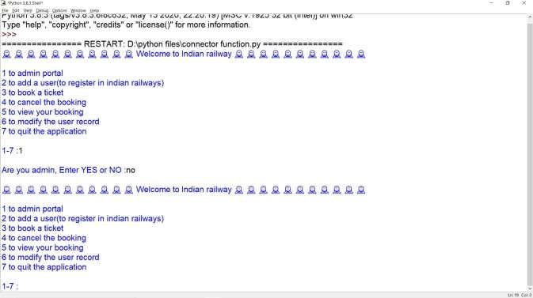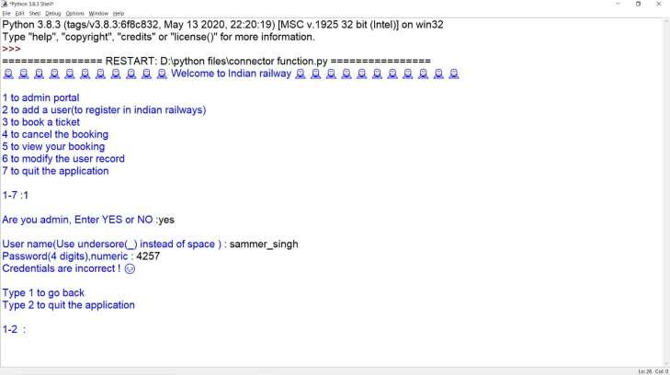

Incorrect user name and incorrect user password

Incorrect user name and correct password

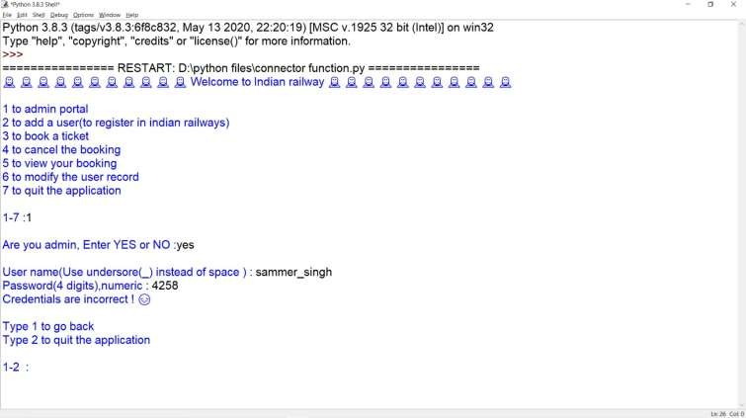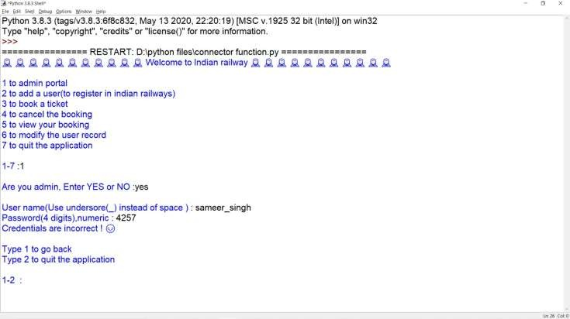

Correct user name and incorrect password

Correct user name and correct user password

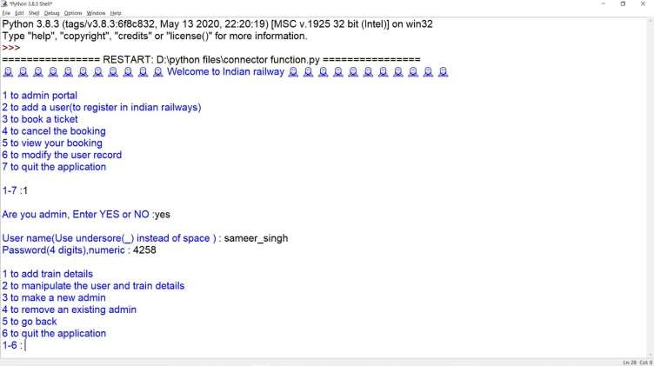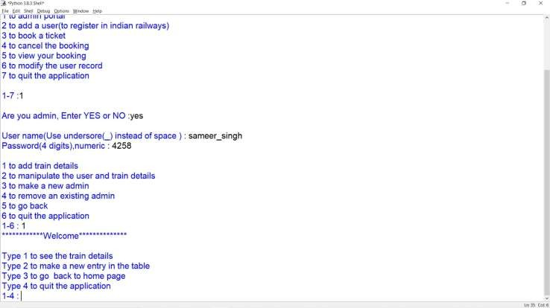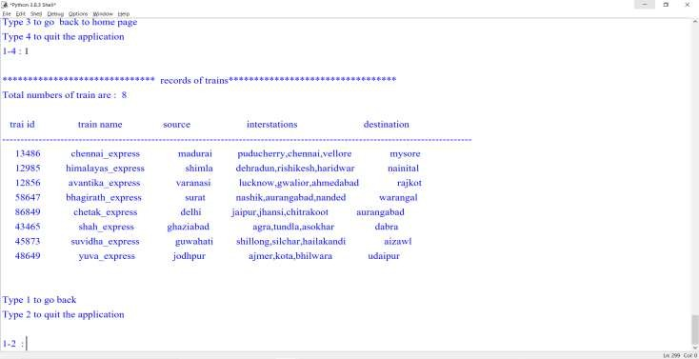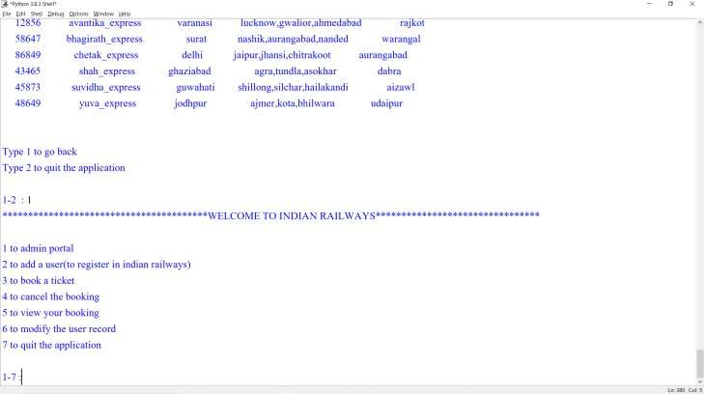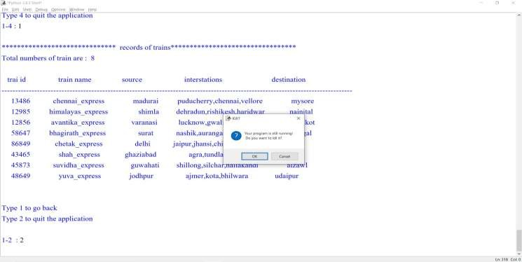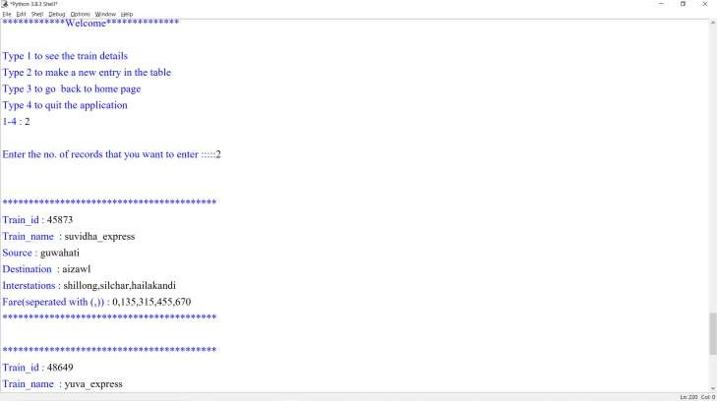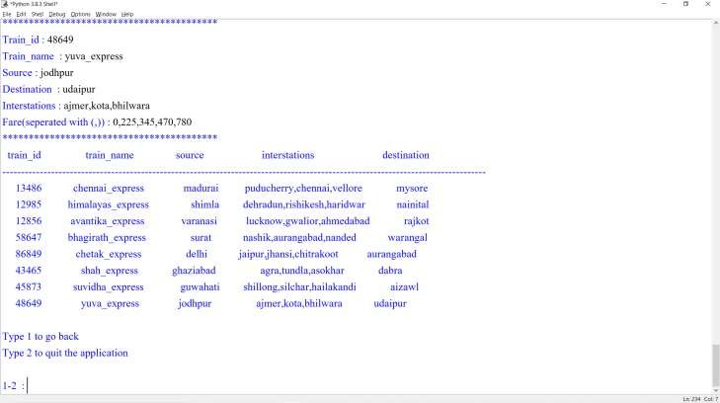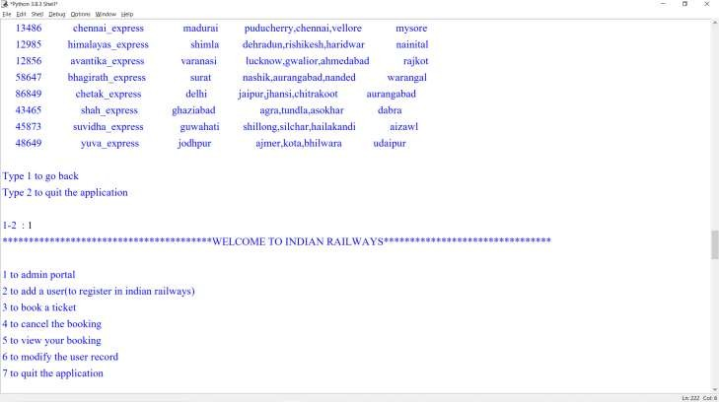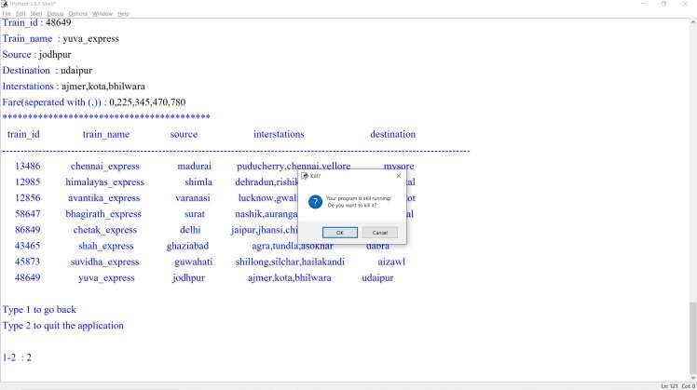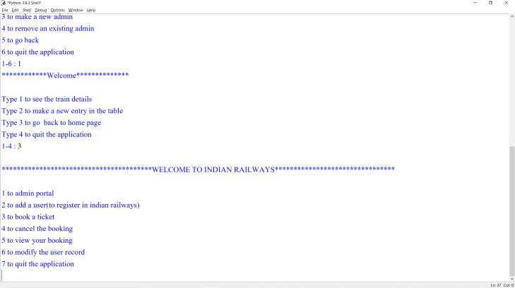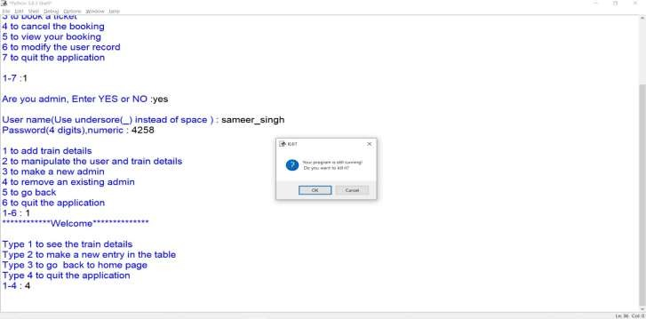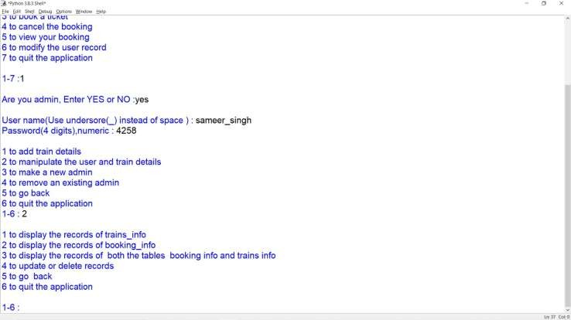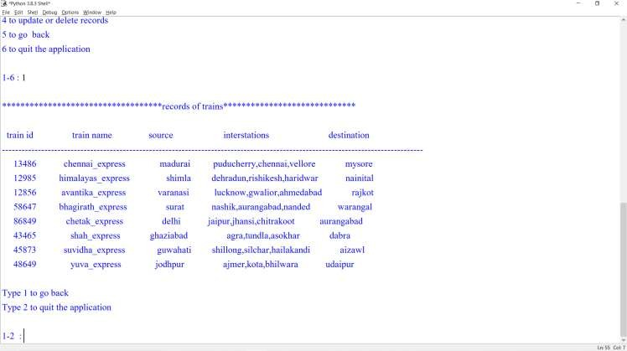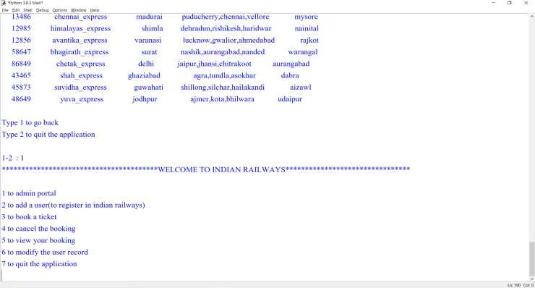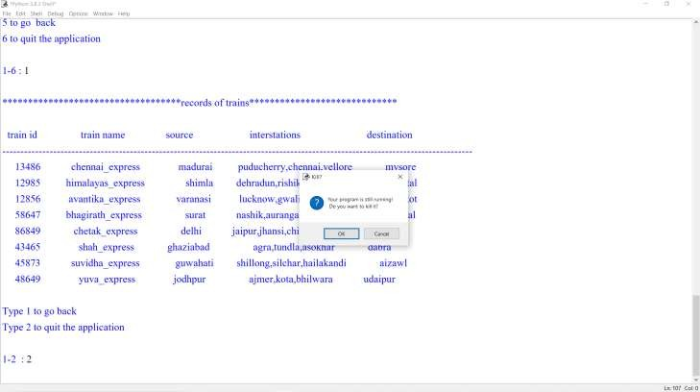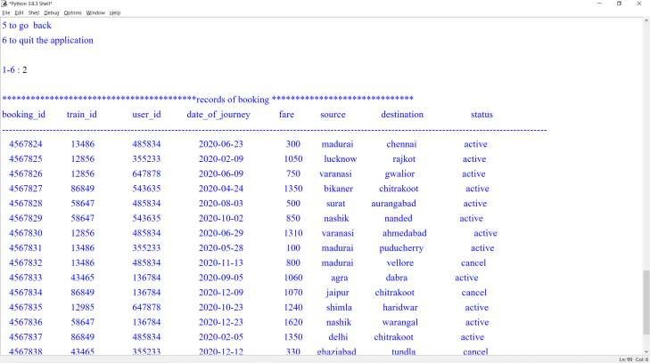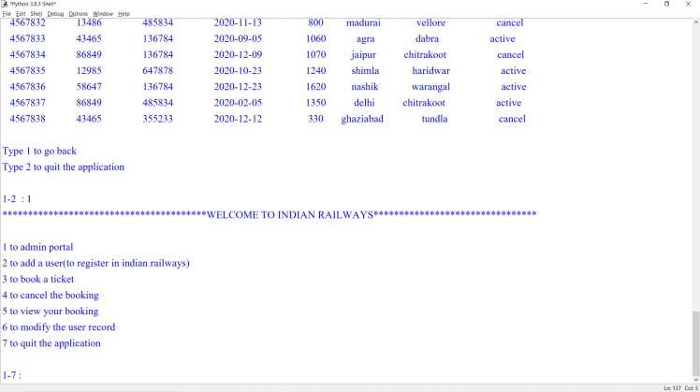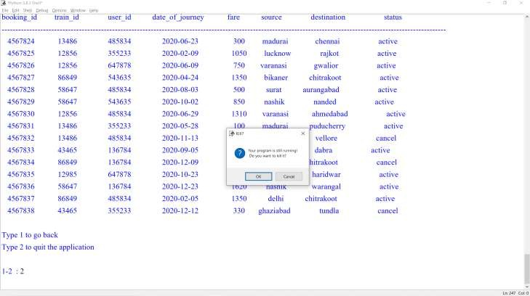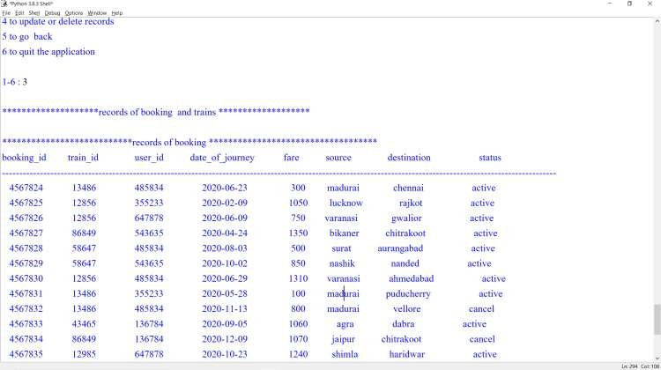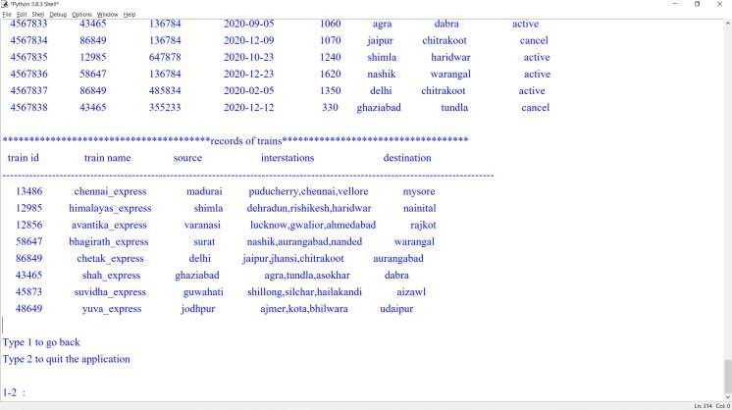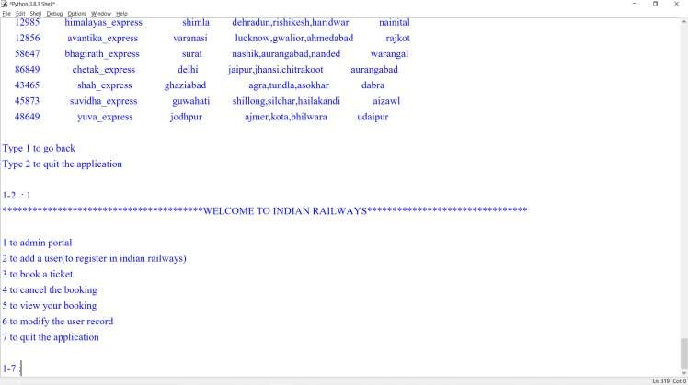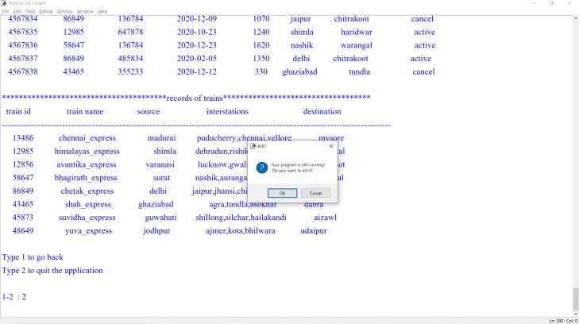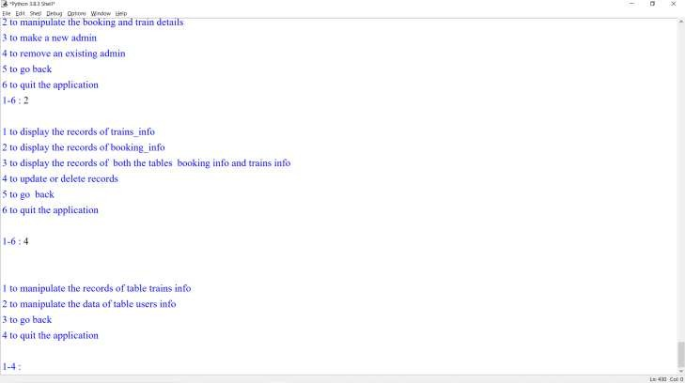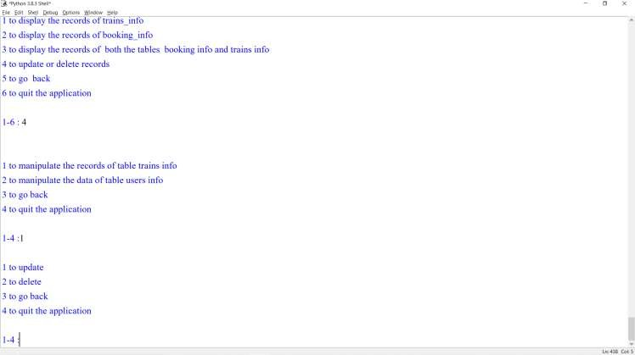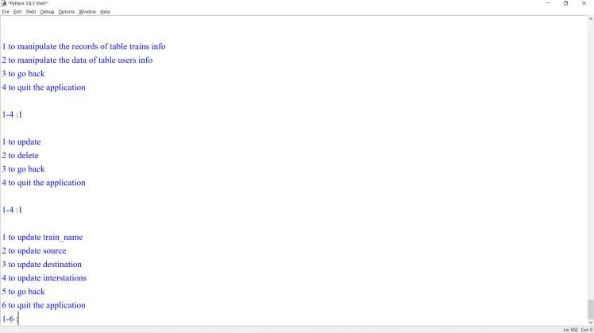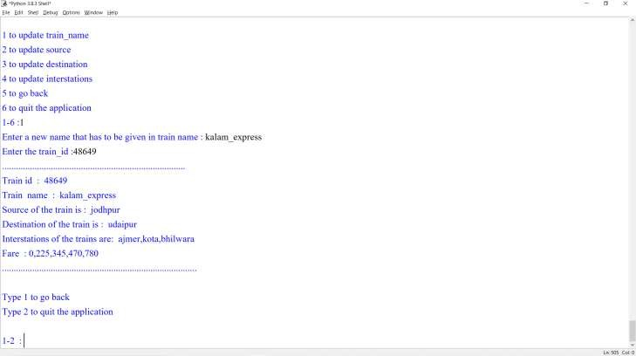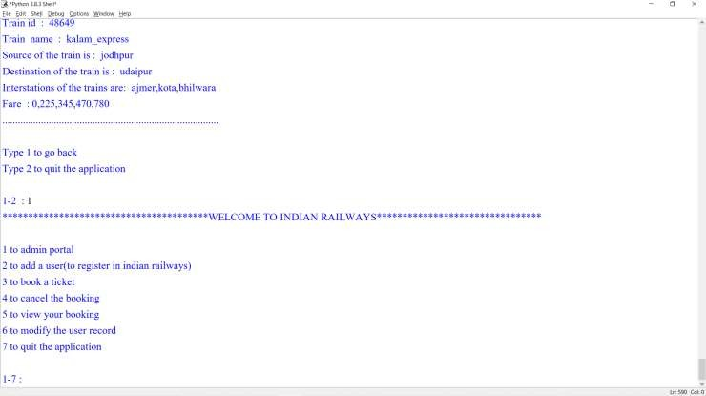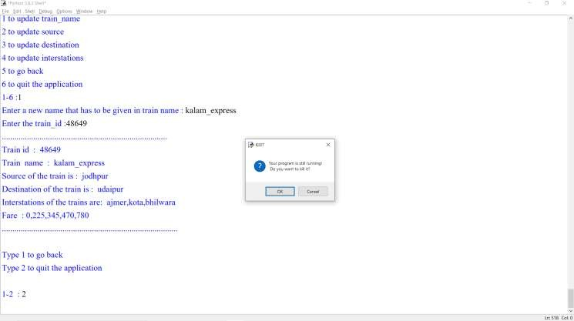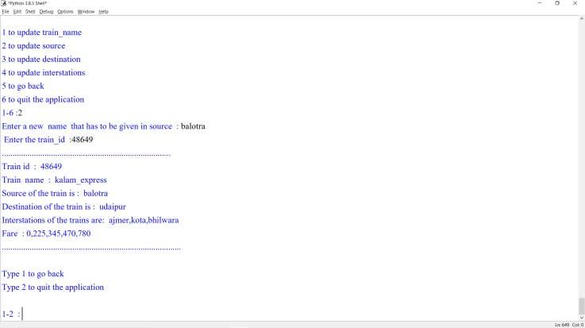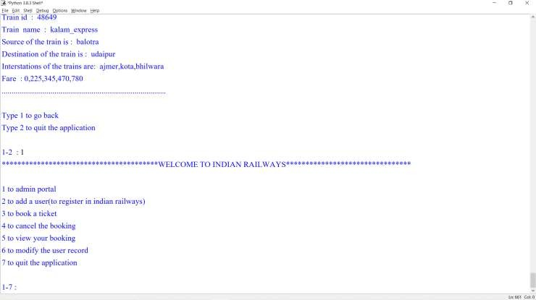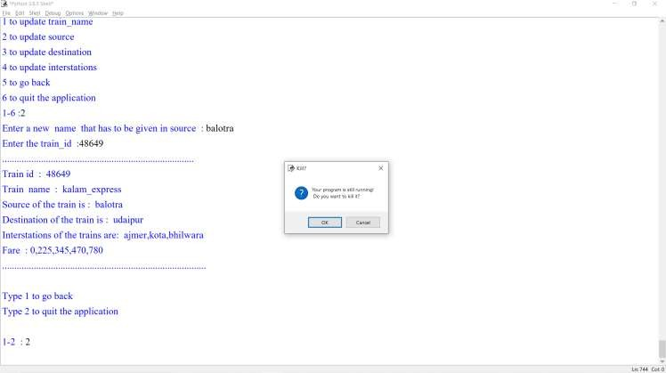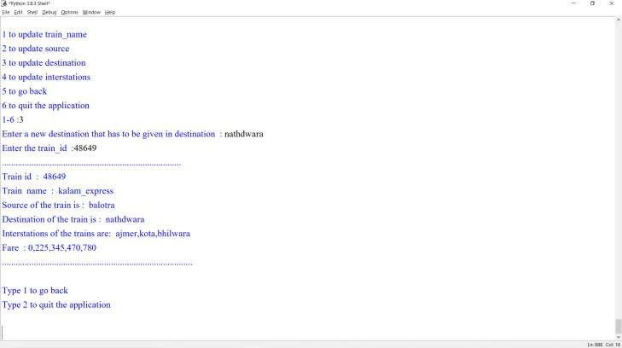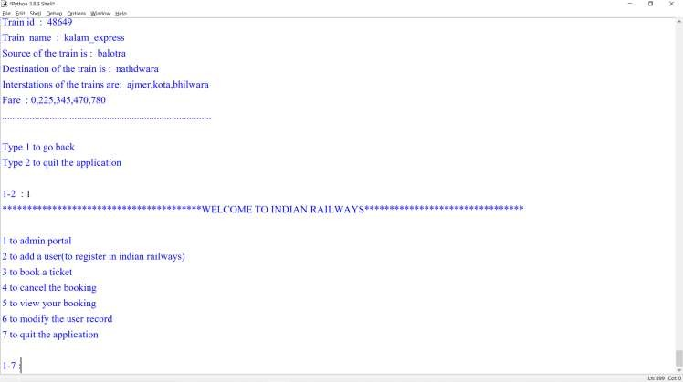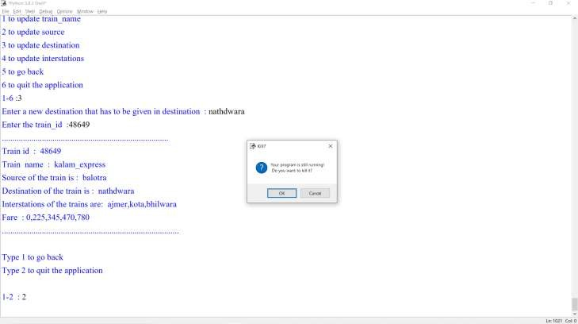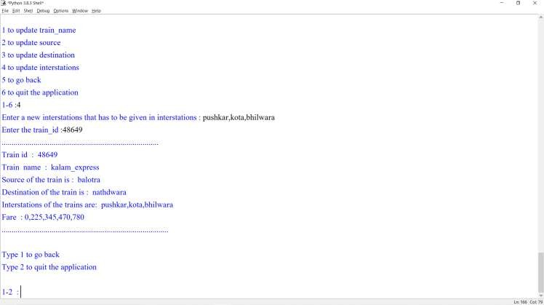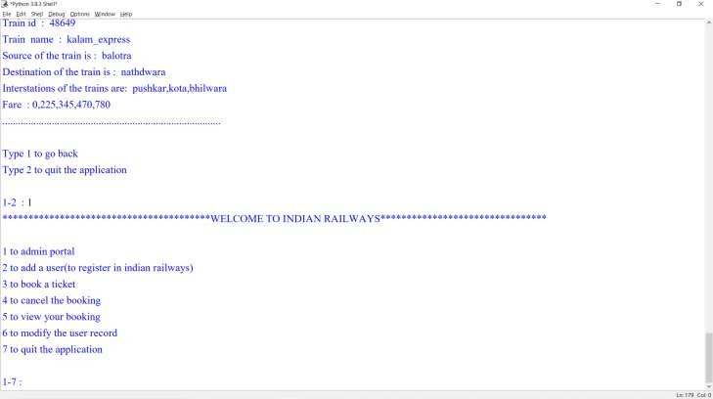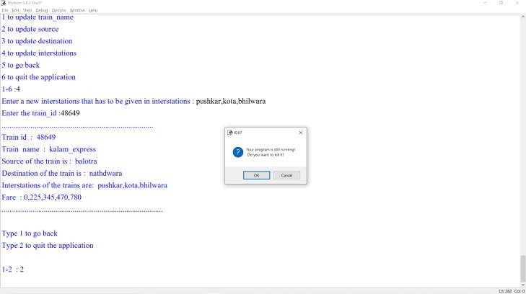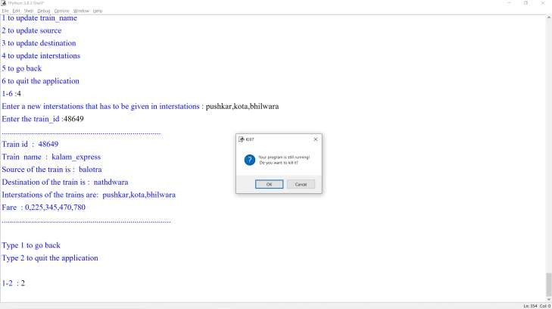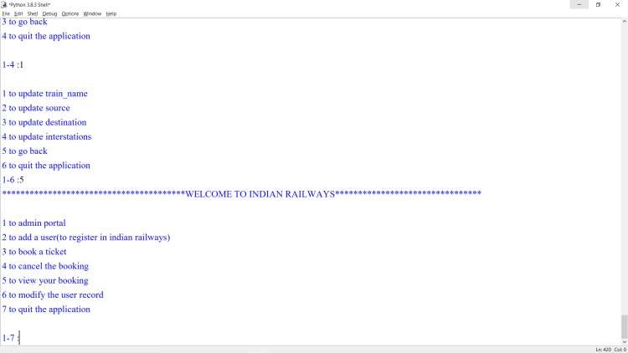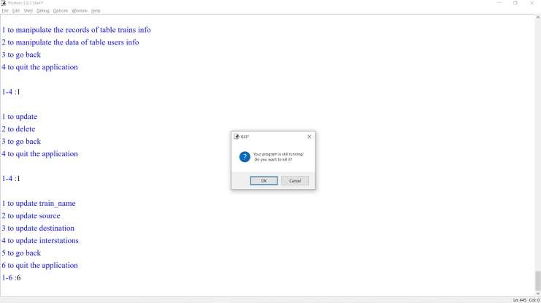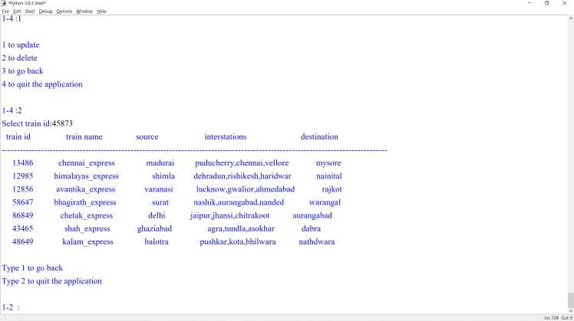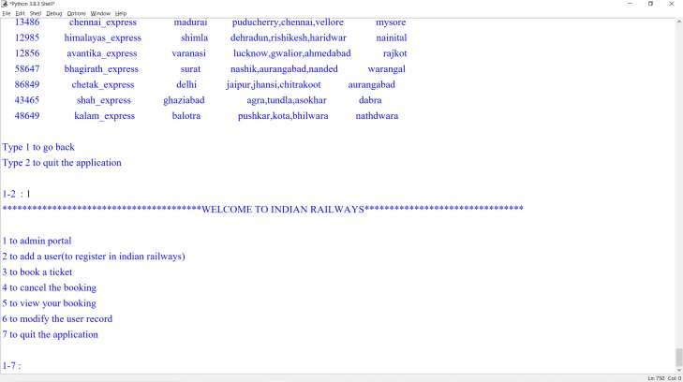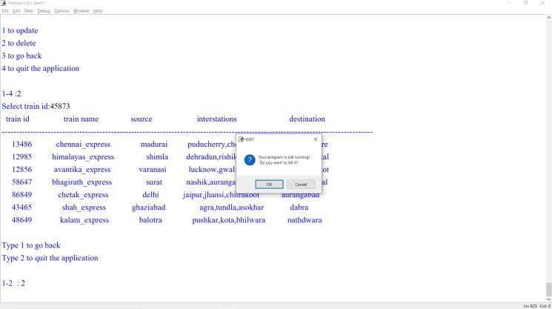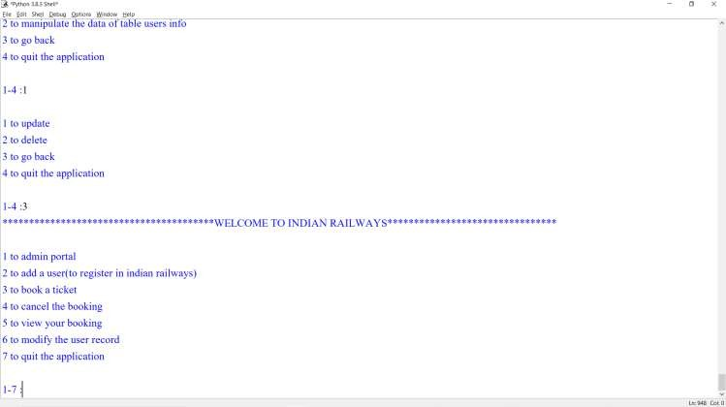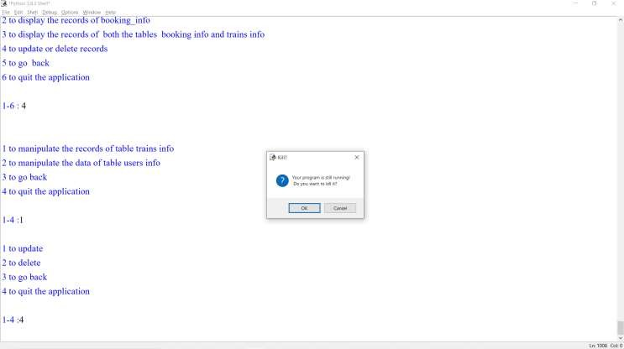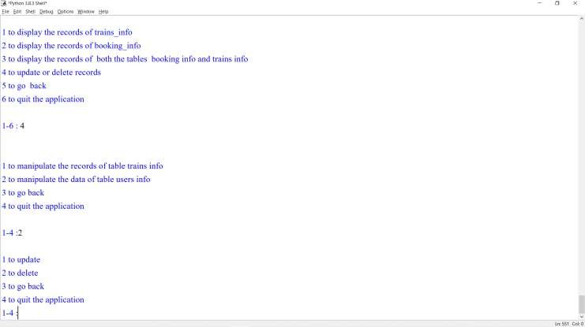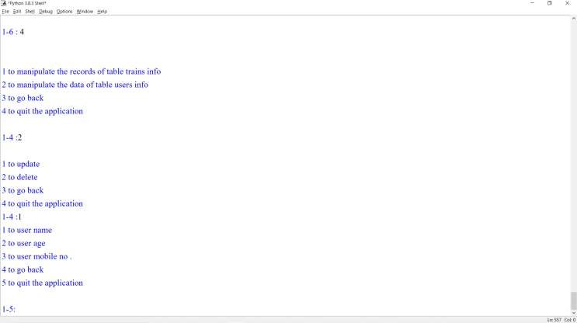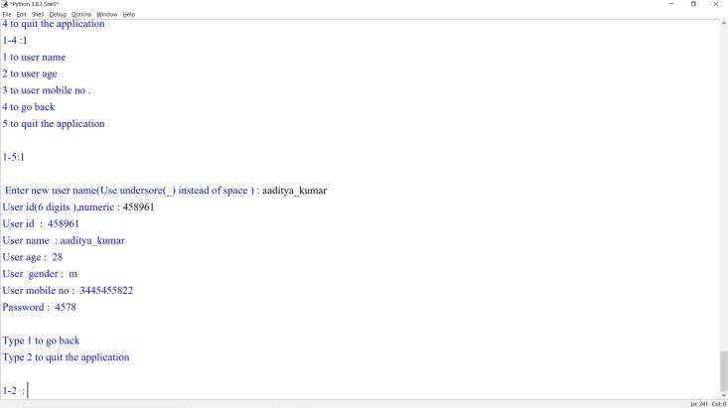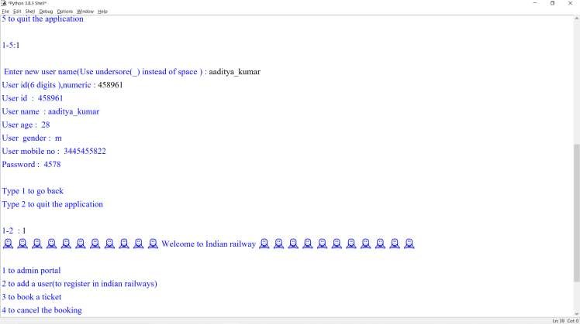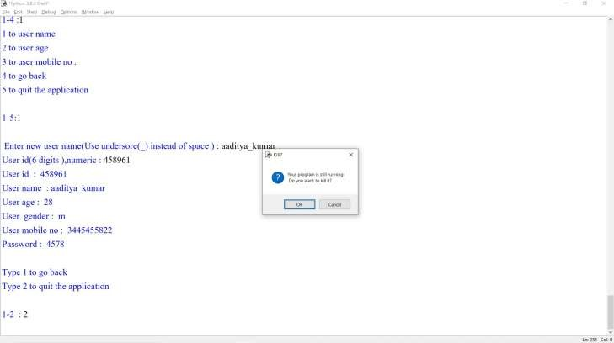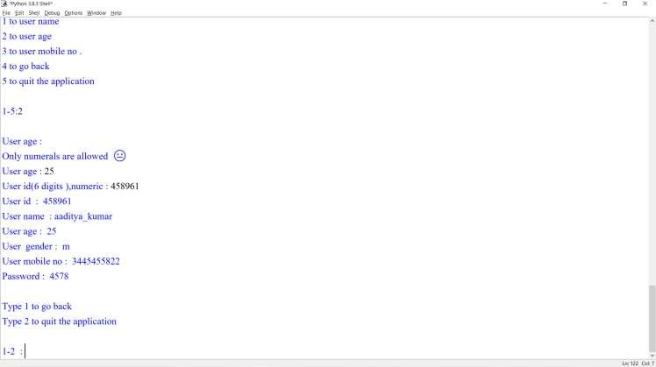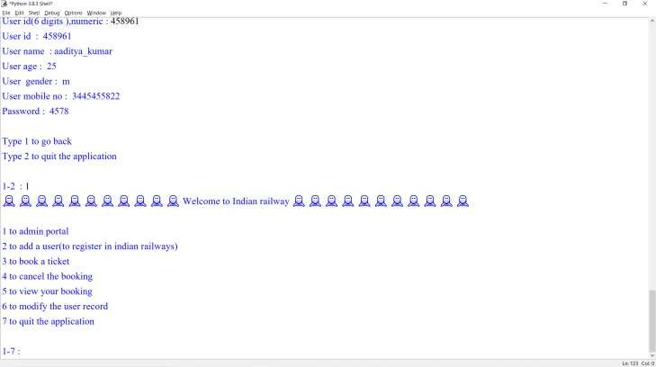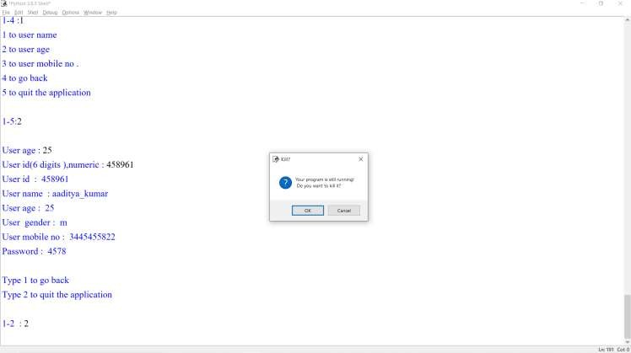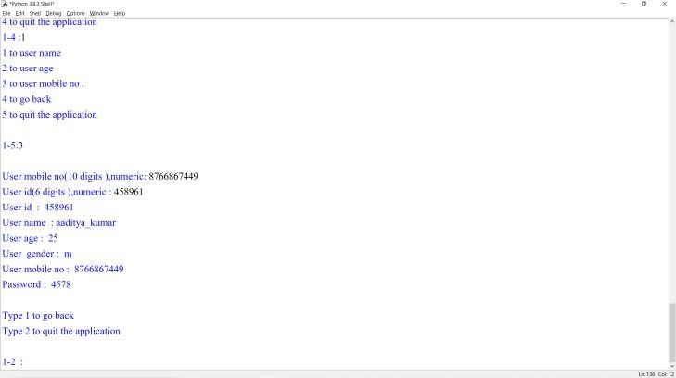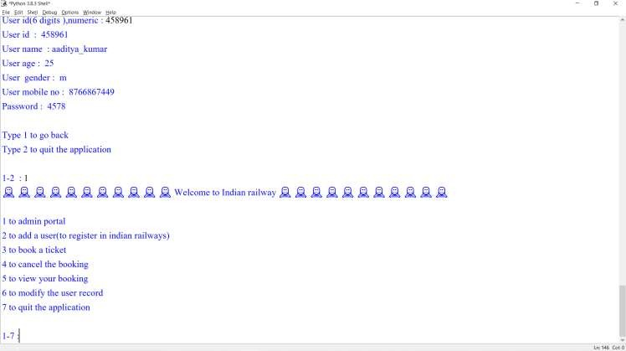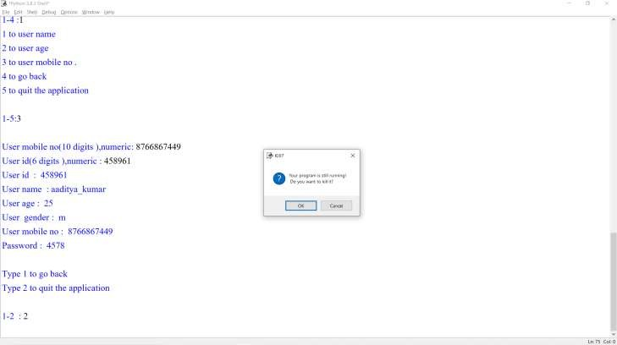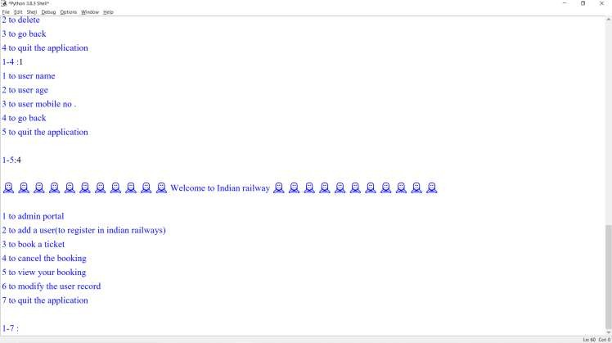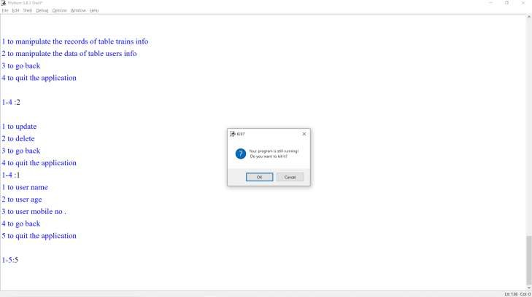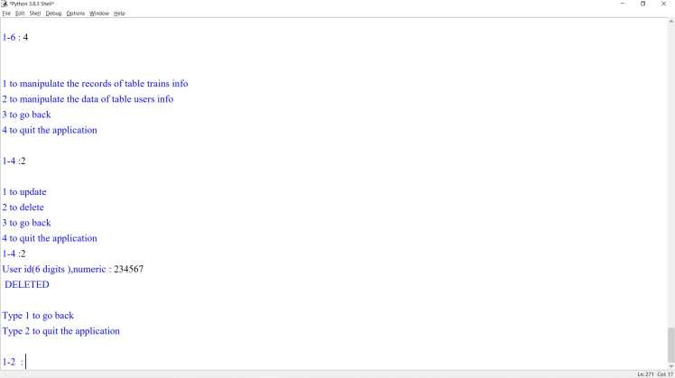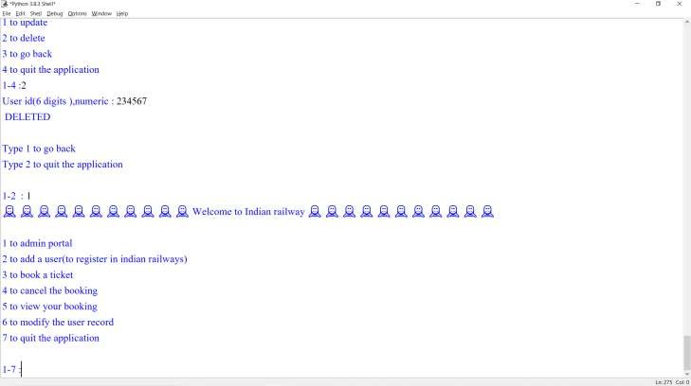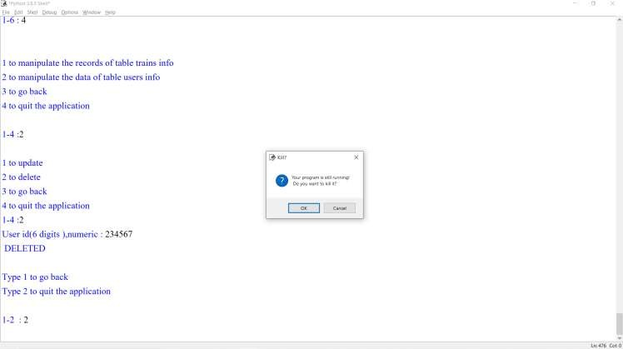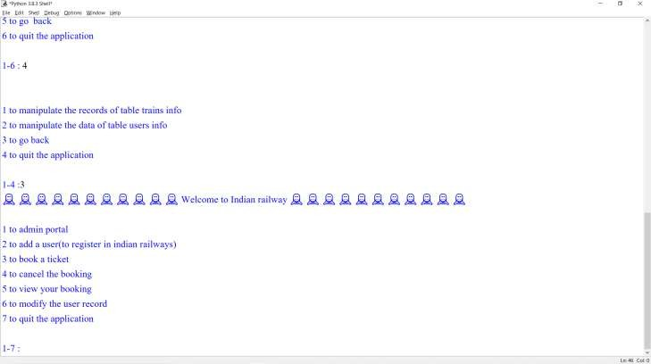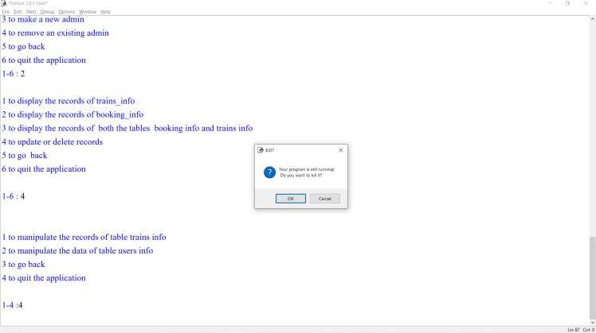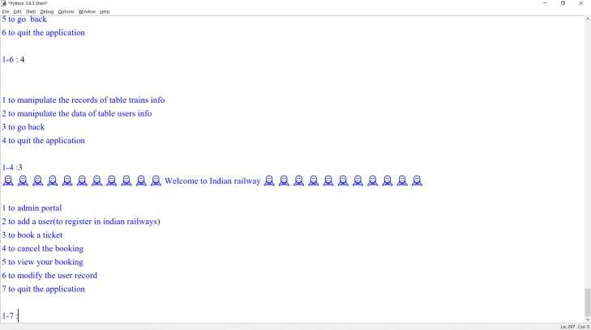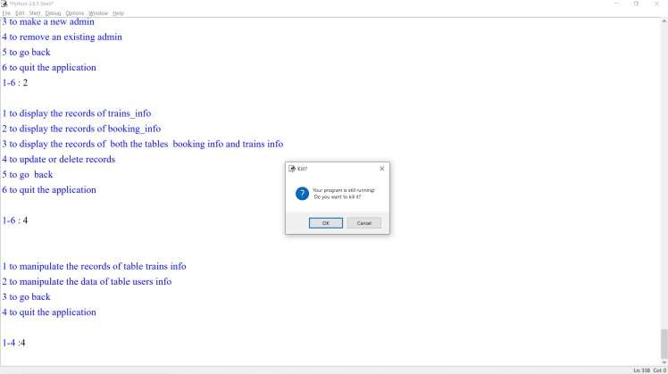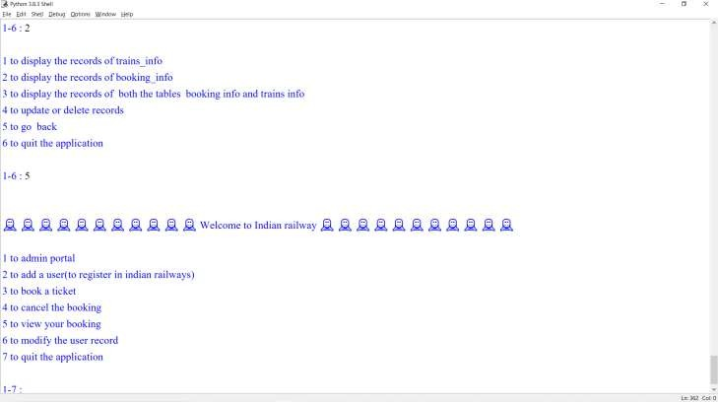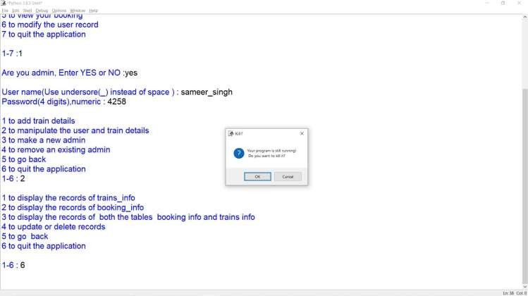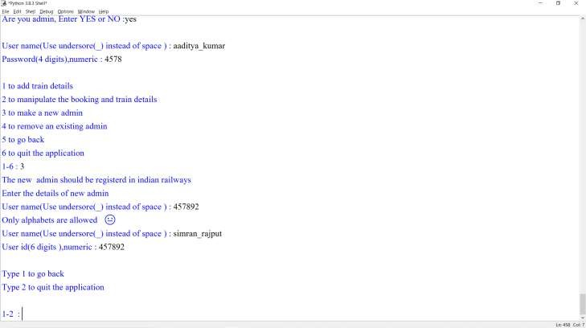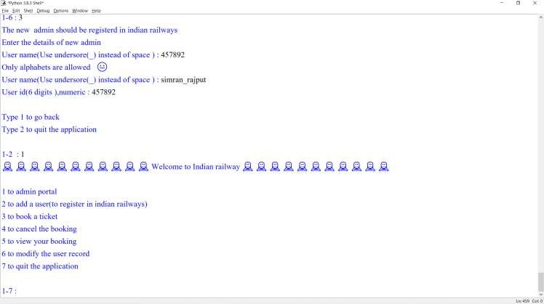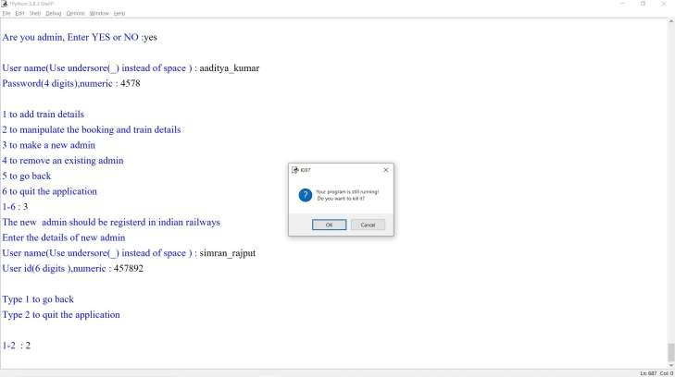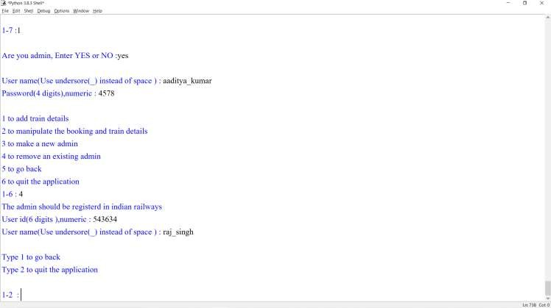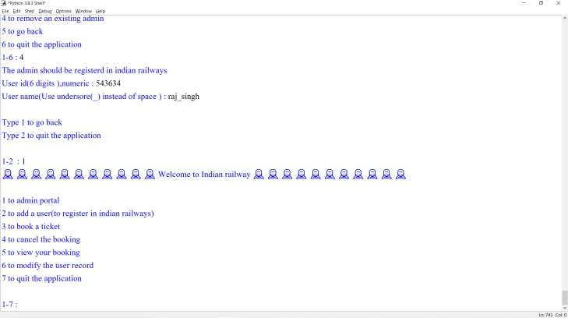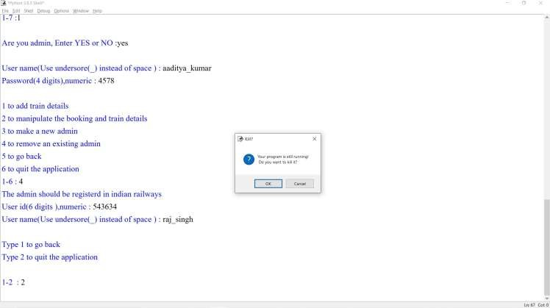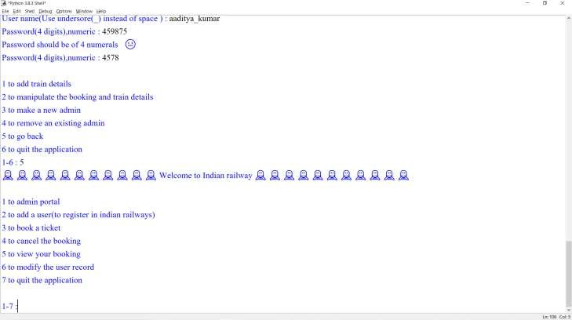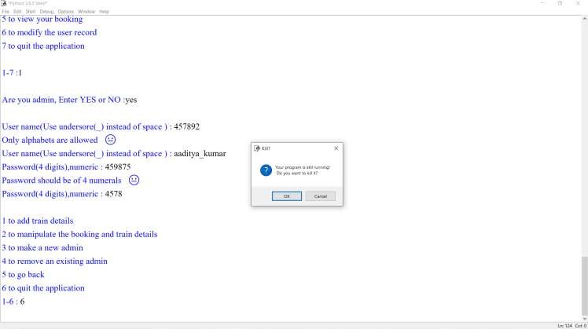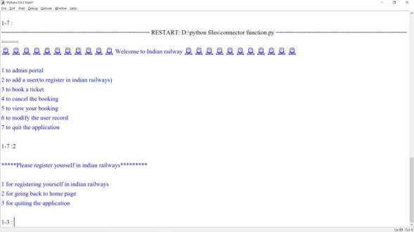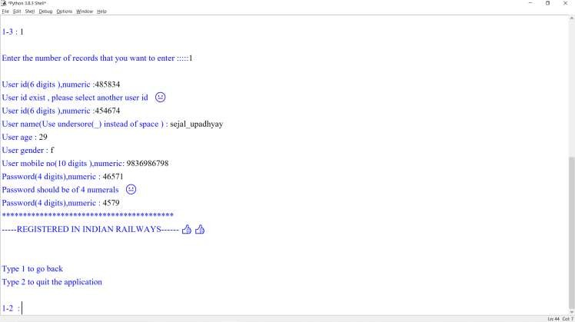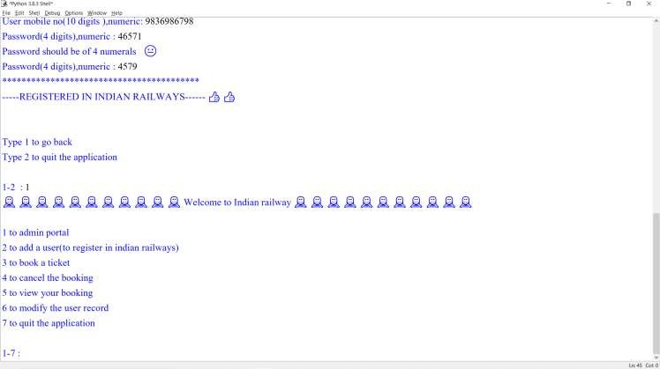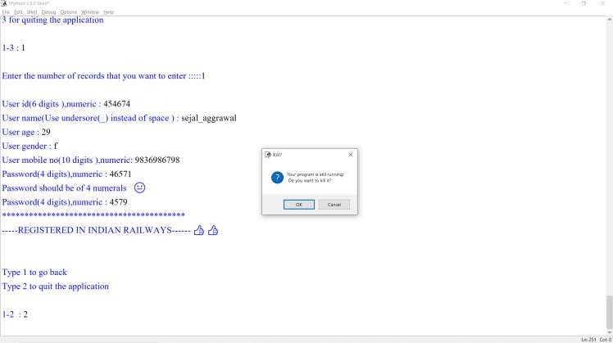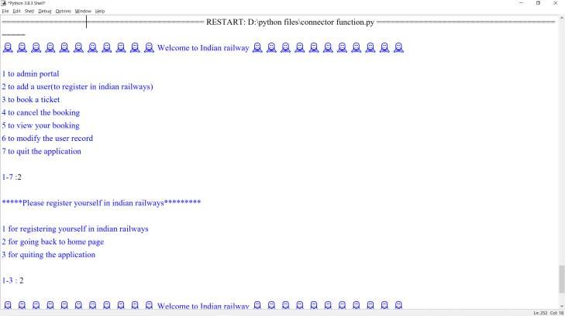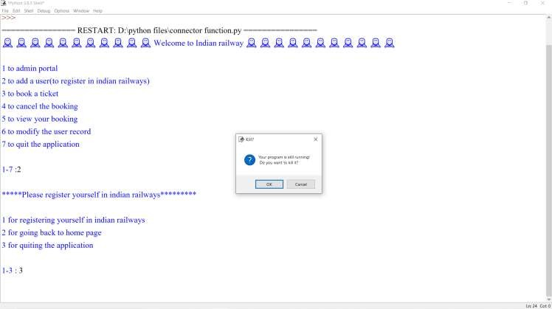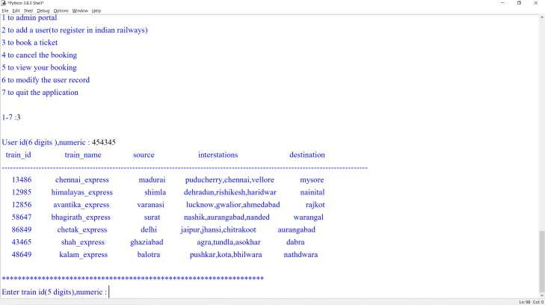

Booking ticket

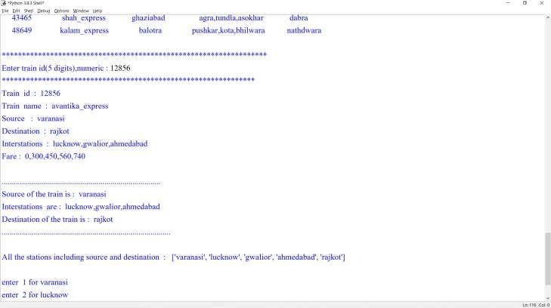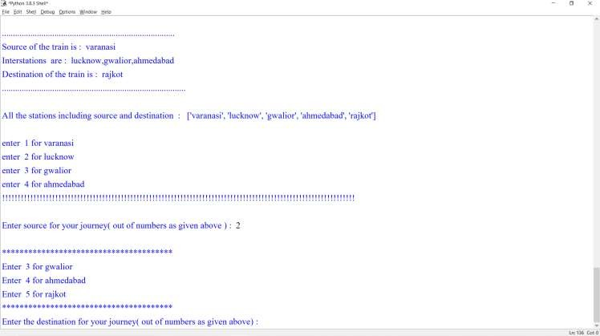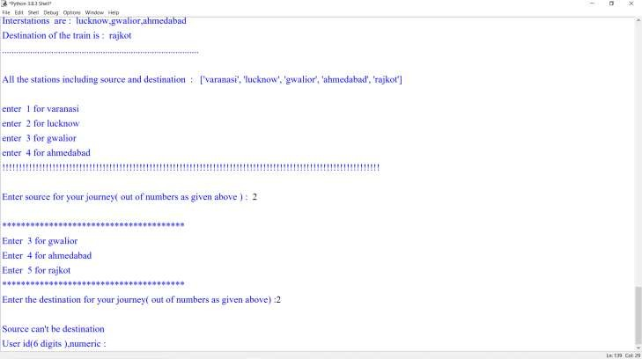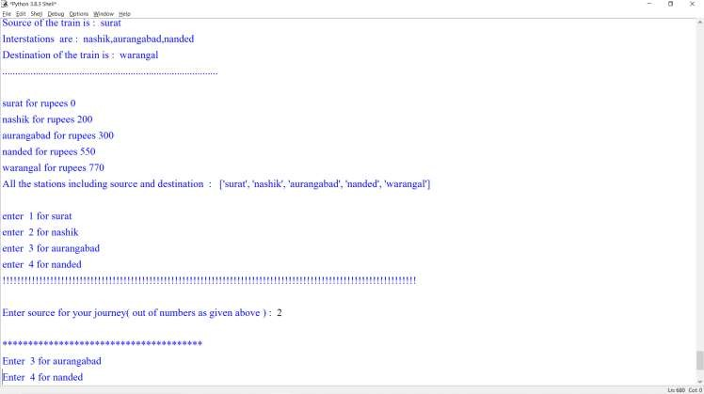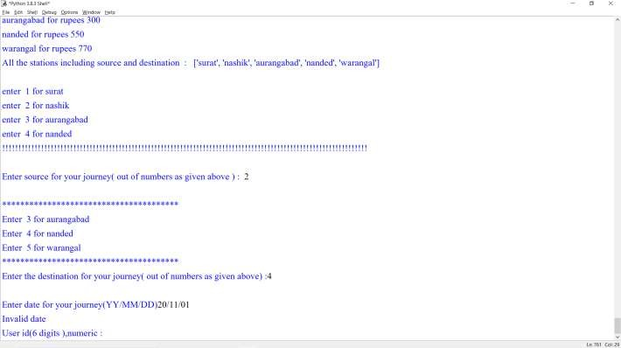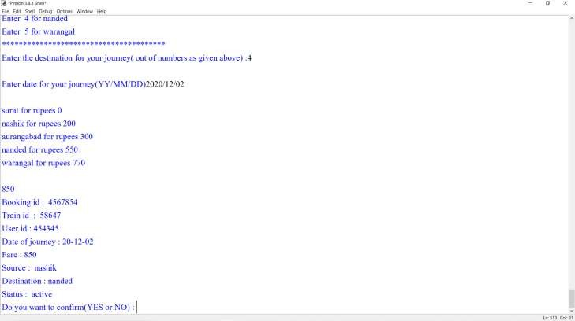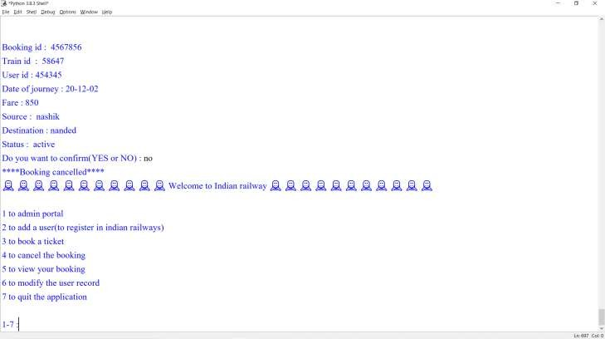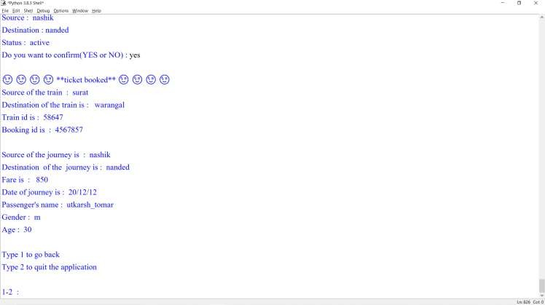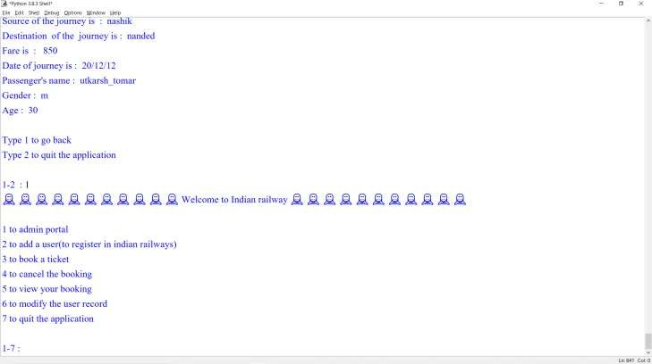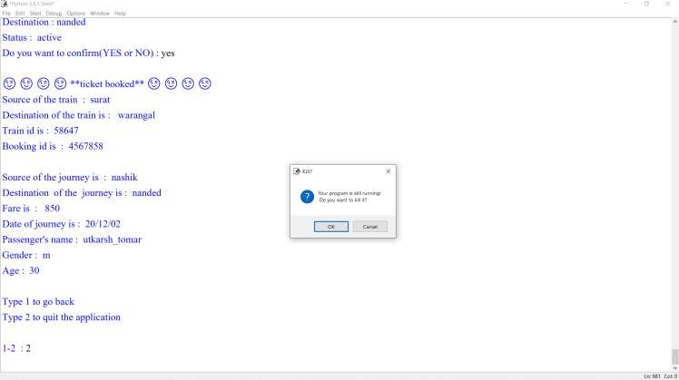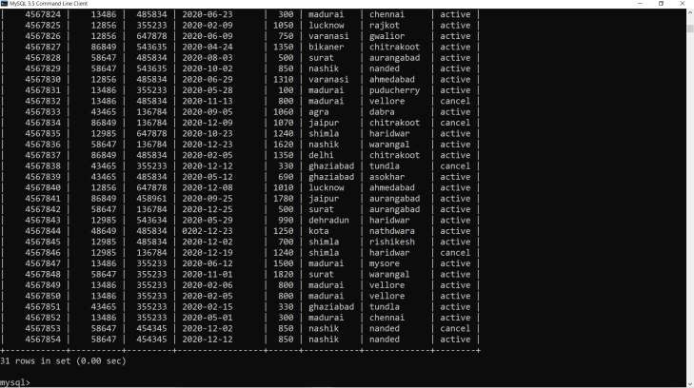

After booking the ticket

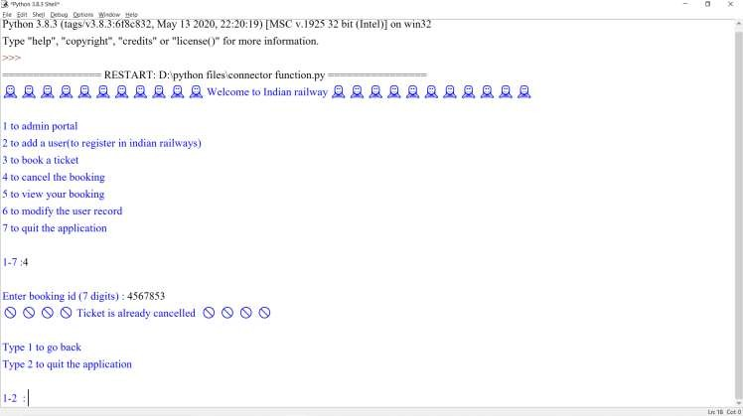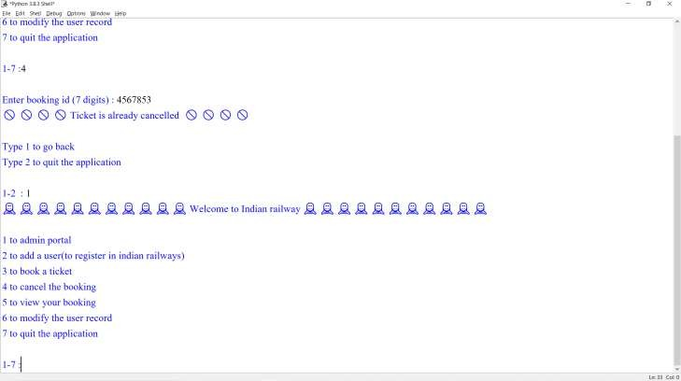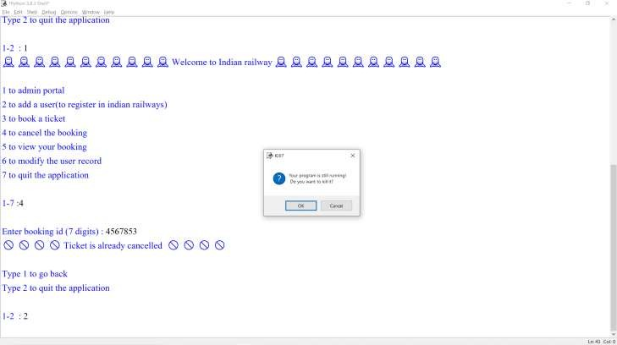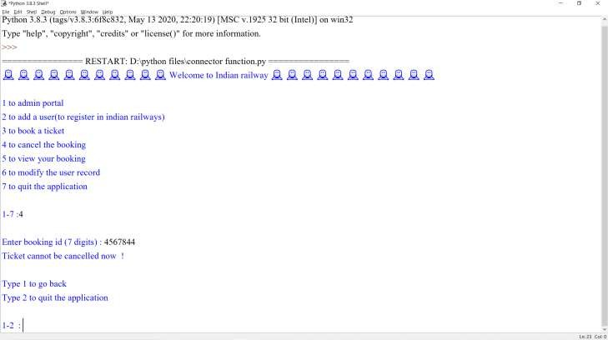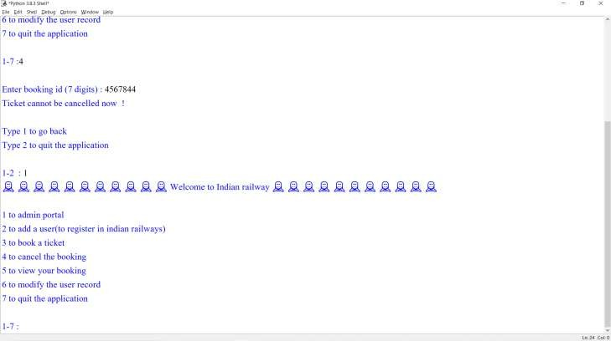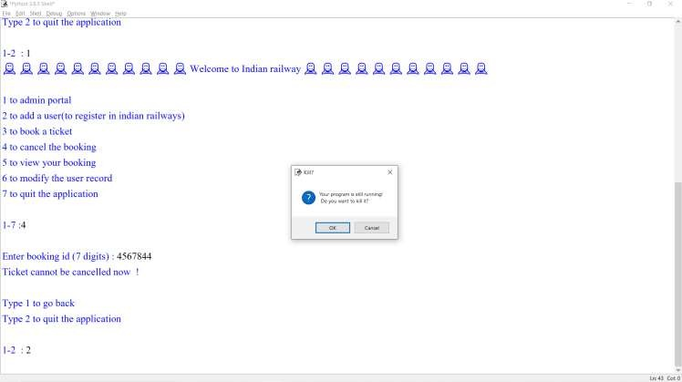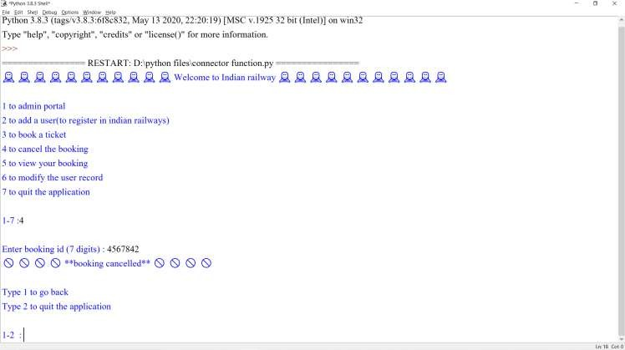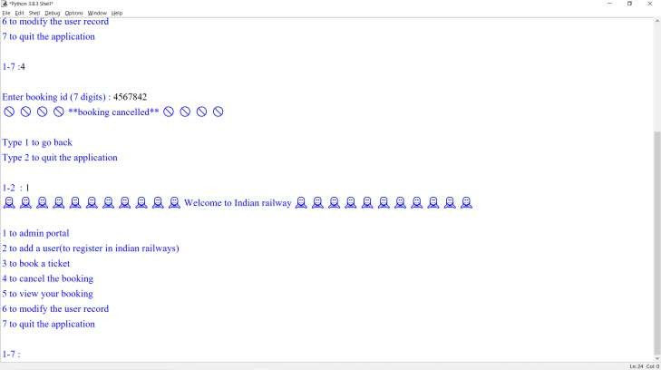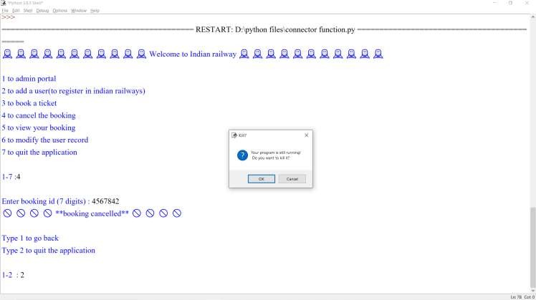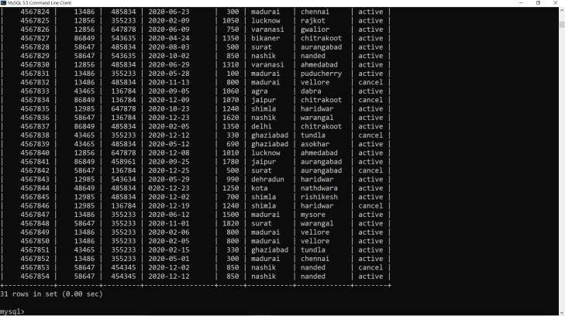

After cancelling the ticket

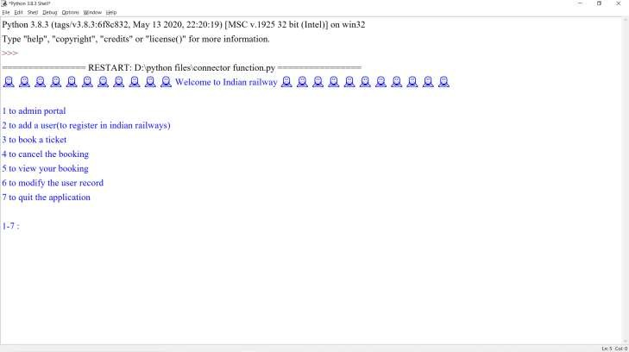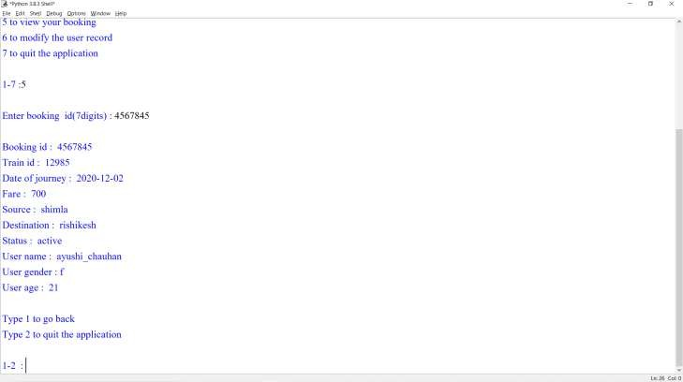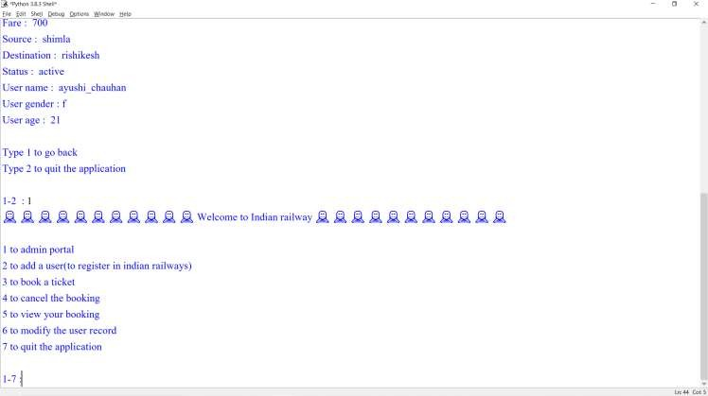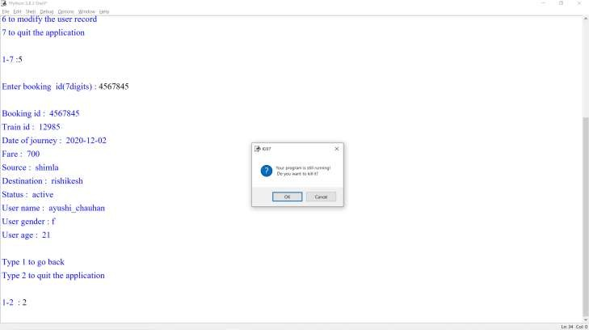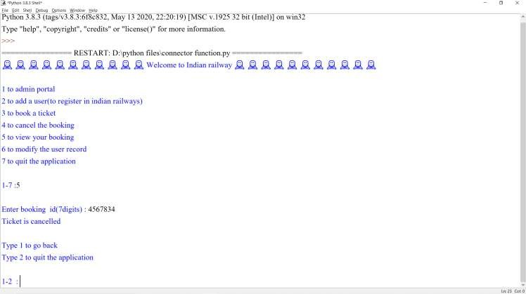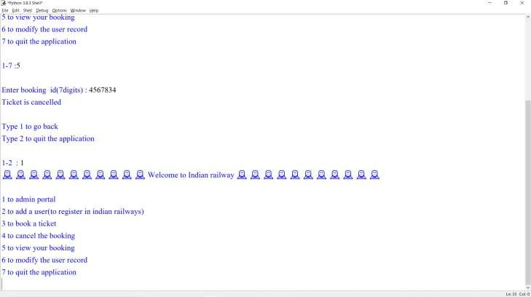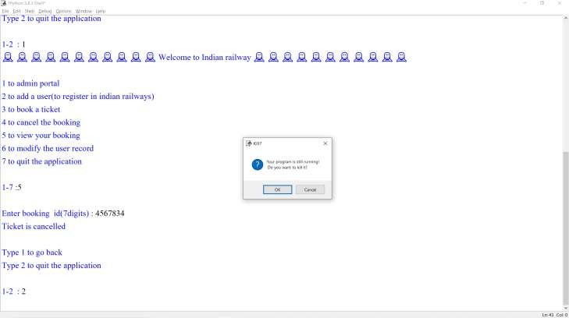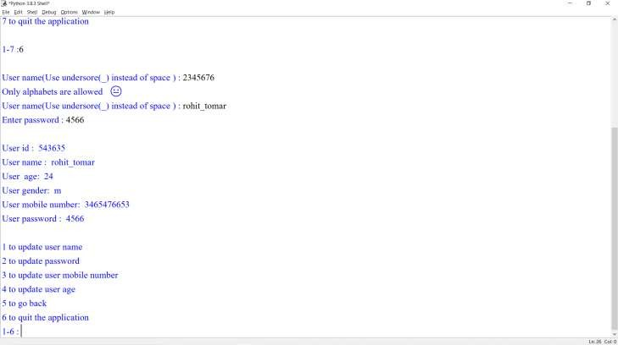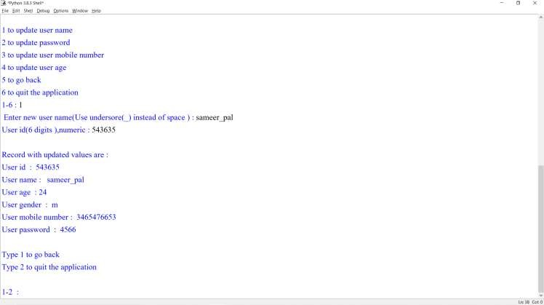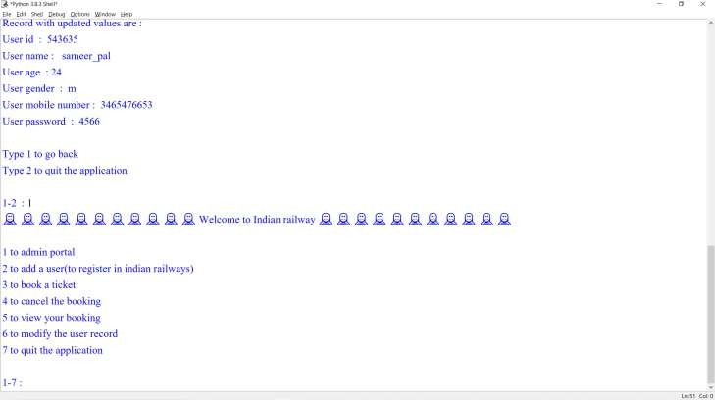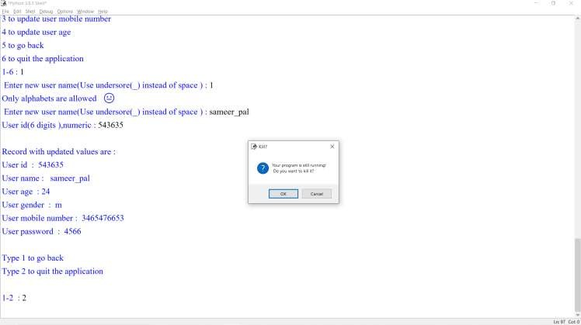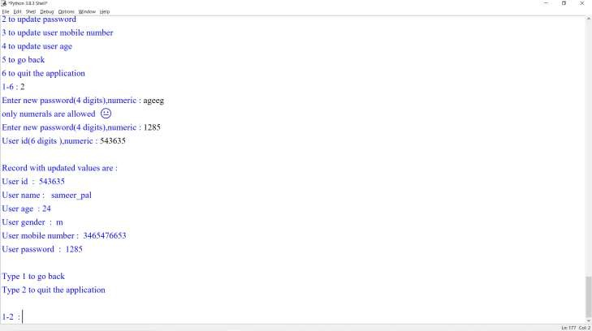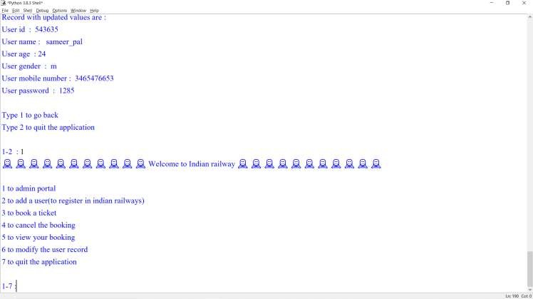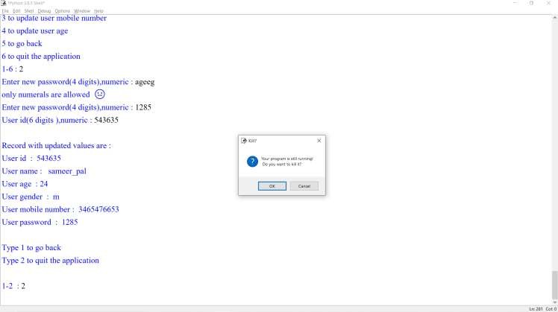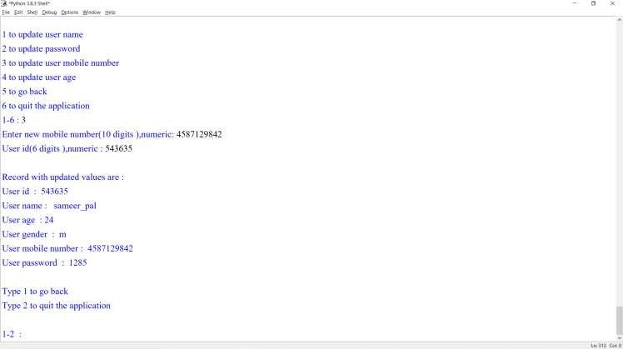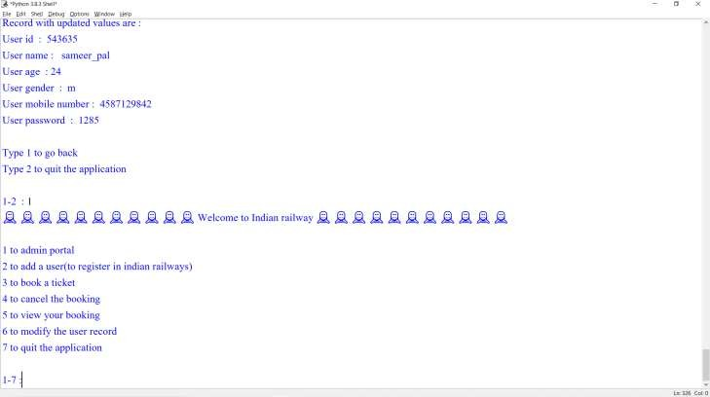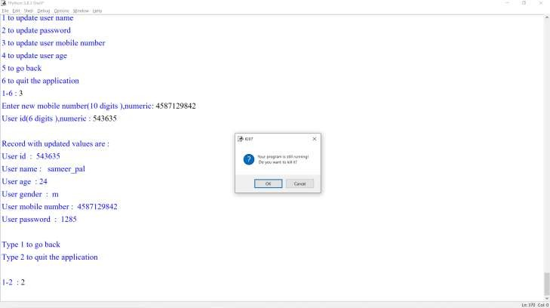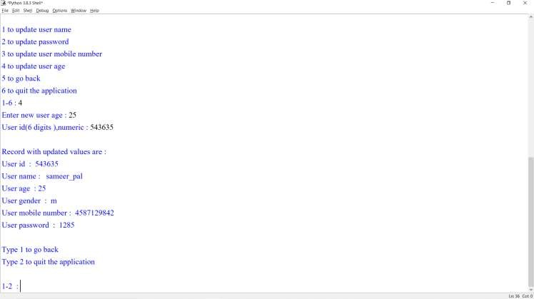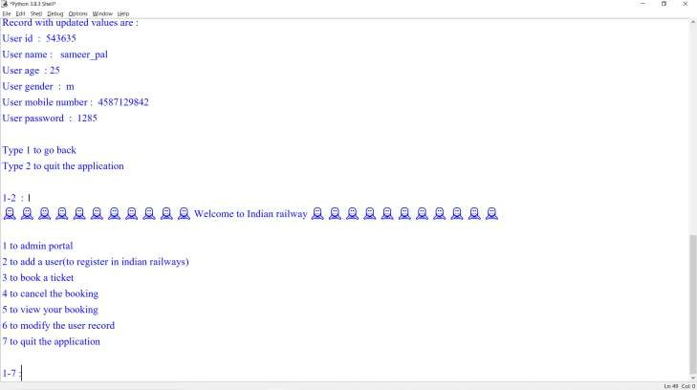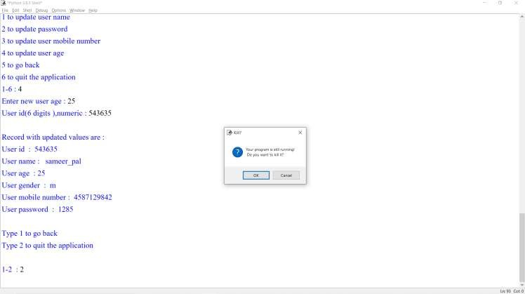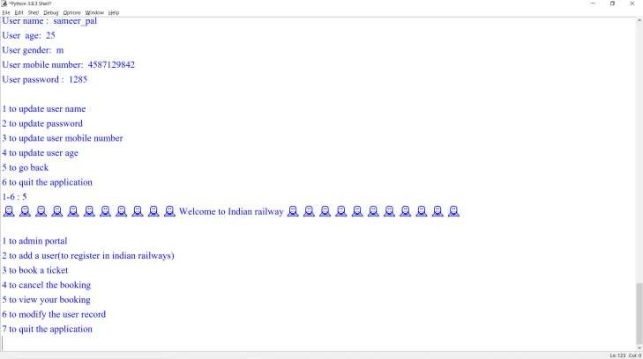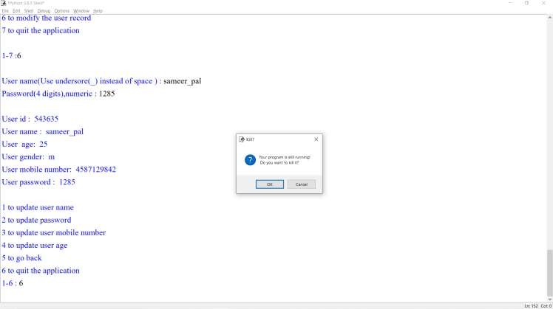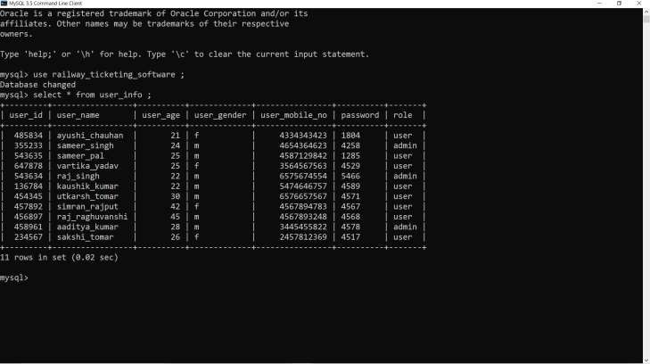

USER TABLE AFTER EDITTING

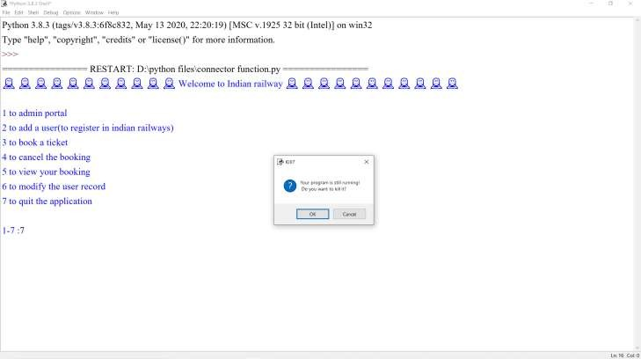

# SCREENSOTS



OF MySQL :

USER TABLE BEFORE EDITING

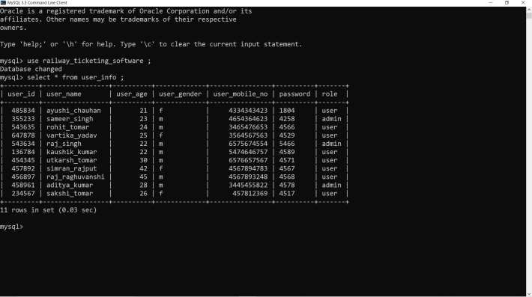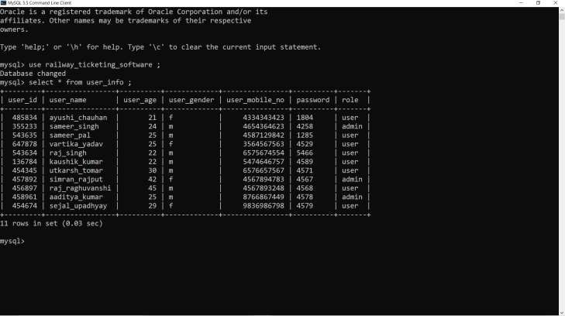

USER TABLE AFTER EDITTING

TRAIN TABLE BEFORE EDITING

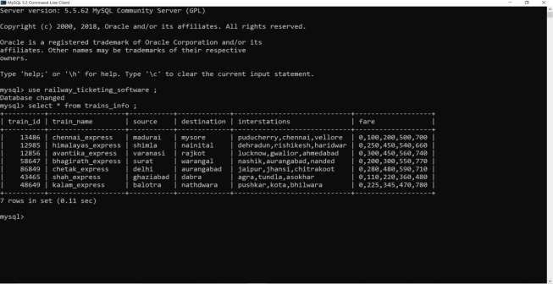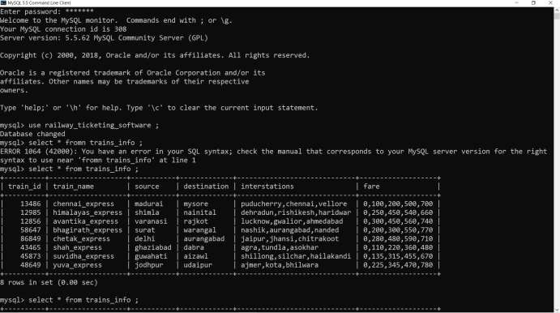

TRAIN TABLE AFTER EDITING

# References



## Subject teacher

1. Internet



# Thank you



